Washington Parish Library
Library Board of Control
Bogalusa Branch
Thursday, January 6, 2022 4:00 PM
Meeting Agenda

I. Call to Order
II. Roll Call
III. Prayer
IV. Pledge of Allegiance
V. Approval of Minutes

VI. Election of Officers

VII. New Business
Appointment of the New Director

VIII. Public Comment
IX. Adjournment

Washington Parish Library
Library Board of Control
Bogalusa Branch
Thursday, January 6, 2022 4:00 PM
Meeting Minutes

I. Call to Order by Mr. Jim Adams
II. Roll Call by Mrs. Etta Magee
Board Members present: Mr. Jim Adams, Mr. Donald Westmoreland, Mrs. Sally Thomas, Mrs. Suzie Betts and Ms. Kewanda August Board Members absent: Ms. Emma Ross and Ms. Luella Jackson
III. Prayer by Mrs. Thomas
IV. Pledge of Allegiance by Mr. Patrick Galivan
V. Approval of Minutes
A motion was made by Mrs. Suzie Betts to accept the November 4, 2021 minutes as written and second by Mrs. Sally Thomas. All Board Members agreed. Motion passed.

VI. Election of Officers
The Board Members slate for 2022 election of officers are as followed Mr. Jim Adams, president, Mrs. Sally Thomas, Vice-president and Ms. Emma Ross, Treasurer. All Board Members agreed. Motion passed.

VII. New Business
Appointment of the New Director
A resolution was read by Mr. Adams. Mrs. Betts made a motion to accepted Mrs. Sonnet Ireland as the new director of the Washington Parish Library System and second by Mr. Westmoreland. Each Board Member voted individually for the new director. The resolution is attached with the minutes. Motion passed.
Mr. Donald Westmoreland Yes
Mrs. Suzie Betts Yes
Mrs. Sally Thomas Yes
Mr. Jim Adams Yes
Ms. Kewanda August N/A
Ms. Emma Ross N/A
Ms. Luella Jackson N/A

Mr. Adams introduced Mr. Ken Wheat, the Parish Government Public Work and the Friends of the library Ms. Mary Jo Poole, Ms. Terri Seal and Mrs. Ann Tate. Mrs. Etta Magee introduced the each Library staff.
VIII. Public Comment
Ms. Melanie Charrier thank the Friends for all they do for the library and how much we appreciated it.
Mrs. Winola Holiday informed the Board that we had received the Art Council Grant and IP Grant. She said these grants will help with buying books, and incentives for the programs we have. Mr. Adams thanks them for getting these grants. Mrs. Winola and Ms. Marian wrote the Art Council grant and Melanie wrote the IP grant.
Mr. Ken Wheat on the behalf of the Parish President welcomed Mrs. Ireland and thanks Mrs. Magee, the Friends and Mr. Adams for all their hard work.
Mrs. Magee thanks the Board for having confident in her to be Acting Director, the Friends for all their help and the staff.
Mr. Adams thanks Mrs. Magee for being there for him.

IX. Adjournment
A motion was made to adjourn by Mrs. Thomas and second by Mrs. Betts. All Board Members agreed. Motion passed.

Washington Parish Library
Library Board of Control
Franklinton Branch
Thursday, March 17, 2022 5:30 PM
Meeting Minutes

- Call to Order by Mr. Jim Adams
- Roll Call by Mrs. Sonnet Ireland
Board Members present: Mr. Jim Adams, Mrs. Sally Thomas, Mrs. Suzie Betts, Ms. Kewanda August, Ms. Emma Ross, and Mr. Donald Westmoreland
Board Members absent: Ms. Luella Jackson
- Prayer by Mrs. Thomas
- Pledge of Allegiance by Mr. Patrick Galivan
- Approval of Minutes
A motion was made by Ms. Ross to accept the January 22, 2022 minutes as written; seconded by Mrs. Thomas. All present Board Members agreed. Motion passed.

- Director’s Report
  - Library Activity (See Attached Report)
  - Annual Report
Mrs. Ireland is still working on gathering all of the Library statistics for the State Library of Louisiana. The deadline is March 31st, so the information for 2021 will be ready for the next Board meeting. This will be much smoother next year.
  - Finance report
Mrs. Ireland is working with the parish to get the completed budget information for 2021 for the state statistics, so there should be an update on this for the next Board meeting as well.
Mr. Adams mentioned that the Lions Club had donated $1,000 to the Library for programming in 2021, but he was unsure what had become of that money. Mrs. Ireland said she would look into it.

- Bulletins/Correspondence (5 min)
  - State Library of Louisiana
Mrs. Ireland has had a few phone meetings with staff from the State Library as she settles into her new position. There will be an orientation at a future date.
  - Community
Mrs. Ireland is interested in reaching out to the community to promote the Library.

- Unfinished Business
  - Angie Branch
Without any way to fund building a new branch, this project is suspended for now. May need to look at a new millage to increase revenue in order to accommodate the needs in Angie. We need to get the community’s support. We must make arrangements to attend the Angie Town Meeting.
  - Bogalusa Branch
    - Covered walkway
There is a leak in the covered walkway at the Bogalusa branch. It will cost around $10,000 to repair.
A motion was made by Mrs. Betts to take $10,000 from the budget to repair the walkway covering; seconded by Ms. Ross. All present Board Members agreed. Motion passed.
    - Expansion (parking lot property)
With talk about expanding the Bogalusa Branch, Mrs. Ireland wanted to verify that the lot currently being used for hospital parking actually belongs to the Library. It does, though there is a chance that the hospital is unaware of this. The expansion of Bogalusa is another project that must be put on hold while we focus on necessary repairs to the branches.

  - Enon Branch
    - Expansion of Covering
The Enon Branch’s current roof covers the porch but not the handicapped accessible ramp. Mrs. Ireland noted that it would be helpful and safer if we could extend the roof to cover the ramp and a portion of the handicapped parking on the side.
Mr. Adams requested that Mrs. Winola Holliday, as Enon Branch Manager, submit a written request to Mrs. Ireland about the situation.
  - Franklinton Branch
    - Roof
The Franklinton Branch roof was damaged by Ida in August 2021. We have received some money from the insurance agency to fix the roof.
Mr. Adams noted that it would probably be best to evaluate the air conditioner at Franklinton before beginning the roof repair.
A motion was made by Ms. Ross to start the Franklinton roof repair project underway in the next 30 days; seconded by Mrs. Betts. All present Board Members agreed. Motion passed.
    - Road to staff parking
The staff parking lot at Franklinton is often impacted by the weather because of its gravel nature. Hopefully, the parish can pave the lot for us, which will give us more room for staff cars.
A motion was made by Mrs. Betts to give the parking lot project to Mr. Ken Wheat, Director of Public Works; seconded by Mrs. Thomas. All present Board Members agreed. Motion passed.
  - Thomas Branch
    - Expansion
Mrs. Ireland wanted to get an idea of the status of the project to expand the Thomas Branch to include storage space and a meeting room. It is currently on hold as repairs are being made at other branches.
    - Paint
There was a plan to repaint the Thomas Branch when the ramp was added, but that did not happen. We need to pressure wash the branch and, ideally, have it painted.
Mr. Adams requested that Mrs. Lahoma Dawson, as Thomas Branch Manager, submit a written request to Mrs. Ireland about the situation.
  - Review of changes in Part-Timer Holiday/Leave Pay
Mrs. Ireland requested permission to analyze the results of changing the part-time holiday and leave pay policy to determine if any money was saved as a result. Permission to investigate was granted by Mr. Adams.
- New Business

  - Approval of Bogalusa Branch Manager
    - Franklinton Assistant Branch Manager
Mrs. Marsha Miley was named the new branch manager of Bogalusa, pending official approval by the Board. The Board was polled via telephone to allow Mrs. Miley to take her new position prior to the official Board Meeting. All Board members approved the choice in the poll.
A motion was made by Mrs. Betts to officially hire Mrs. Miley as the Bogalusa Branch Manager; seconded by Ms. Ross. All present Board Members agreed. Motion passed.
  - Cost of Living Raise
    - Vote
A 2% cost of living raise for staff was budgeted for this year for everyone hired prior to January 2022. This excluded only the director, who started January 31, 2022.

A motion was made by Mrs. Betts to have the 2% cost of living raise for all staff hired prior to 2022 go into effect for the March 14th pay period; seconded by Mr. Westmoreland. All present Board Members agreed. Motion passed.

  - Board Meeting Schedule for 2022
The 2022 schedule was tentatively accepted by the Board by consensus, pending any necessary changes that might arise. There was concern that the May 19th meeting may conflict with graduations in the parish, but it was confirmed that all high school graduations will have occurred prior to that week.

  - New Full-Time Position
Mrs. Ireland expressed interest in using the cost savings from her not using the insurance provided by the Washington Parish Library to turn a part-time position into a full-time position. Her focus was on creating a programming/outreach position to help unify the branches in their programming and outreach work. Mr. Adams suggested this discussion should be continued at a future date, as there are many repair projects that may take up those extra funds.

  - All Staff Training Day
With COVID restrictions easing, Mrs. Ireland was interested in having an All Staff Training Day again. The Board agreed.

A motion was made by Mrs. Ross to allow Mrs. Ireland to close the Library for an All Staff Training Day on a future date to be decided by Administration; seconded by Ms. August. All present Board Members agreed. Motion passed.

  - Fine Forgiveness in April to celebrate National Library Week
Mrs. Ireland has read a few studies about eliminating overdue fines for traditional library materials (books, DVDs, CDs, etc.) that indicate most libraries save money by going fine free. As a result, she would like to try going fine free for 6 months for overdue books, DVDs, CDs. Instead of being charged per day for those items, patrons will receive a bill for the cost of the item once it becomes long overdue. Overdue fines will remain in effect for technology the Library lends out, such as hotspots and laptops, as that is a limited resource in high demand from patrons. A printout of a 2020 white paper by ProQuest called Are Library Late Fees a Barrier to Equity? was included in the packets for the Board.

Mr. Adams supported the idea of giving patrons a fresh start and recommended trying a 6-month pilot program to test it out.

A motion was made by Mrs. Betts to clear any existing overdue fines and start a 6-month pilot program, beginning April 1st, of going fine free for traditional library materials (this will exclude computers and other technology available for checkout); seconded by Ms. Ross. All present Board Members agreed. Motion passed.

  - Library Staff Appreciation Luncheon, hosted by Friends of the Washington Parish Library
Mrs. Ireland asked the Board to vote to close the library on April 6th 11am-2pm in order for the staff to attend a Library Staff Appreciation Luncheon hosted for them by the Friends of the Washington Parish Library.

A motion was made by Mrs. Betts to close all branches from 11am to 2pm on Wednesday, April 6th for the Library Staff Appreciation Luncheon; seconded by Mr. Westmoreland. All present Board Members agreed. Motion passed.

  - Future board member candidates (discussion was held at the end of the meeting)
    - Executive Session - Discussion

A motion was made by Mrs. Betts to go into executive session; seconded by Ms. Ross. All present Board Members agreed. Motion passed.

A motion was made by Mrs. Thomas to come out of executive session; seconded by Ms. August. All present Board Members agreed. Motion passed.

- Parking Lot (for future discussion)
This is a category Mrs. Ireland has added to the Agenda for items that we need to remain aware of but which we cannot focus on at the moment.

- Public Comment - none

- Adjournment

A motion was made to adjourn by Mrs. Thomas and second by Mrs. Betts. All Board Members agreed. Motion passed.

Washington Parish Library
Library Board of Control
Bogalusa Branch
Thursday, May 19, 2022 5:30 PM
Meeting Minutes

- Call to Order by Mr. Jim Adams at 5:50pm
- Roll Call by Mrs. Sonnet Ireland
Board Members present: Mr. Jim Adams, Mrs. Sally Thomas, Ms. Kewanda August, and Ms. Emma Ross
Board Members absent: Mrs. Suzie Betts, Ms. Luella Jackson, and Mr. Donald Westmoreland
- Invocation by Mrs. Thomas
- Pledge of Allegiance by Mr. Patrick Galivan
- Approval of Minutes

Before proceeding, a motion was made by Mrs. Thomas to amend the agenda to include honoring the Young Authors winners to the agenda as Section E under New Business; seconded by Ms. Ross. All present Board Members agreed. Motion passed.

A motion was made by Mrs. Thomas to accept the March 17, 2022 minutes as written; seconded by Ms. Ross. All present Board Members agreed. Motion passed.

- Director’s Report (See Attached Report)

- Bulletins/Correspondence
  - State Library of Louisiana
Had a few meetings with staff at the State Library, who were happy with the Annual
Report – said we did very well in completing it, considering.
Thursday, June 30th, – New Director Orientation.
Thursday, August 11th and Friday, August 12th – New Director Boot Camp
Wednesday, August 17th – Record Retention training
Mrs. Ireland will be talking with the trainers at the State Library about having our Branch Managers take the LSSC (Library Support Staff Certification) class on Supervision & Management. She would like to have Branch Managers and Asst Branch Managers take it, depending on the pricing available. This is a priority for Mrs. Ireland.

  - Community
Mrs. Ireland will be visiting various food pantries, thrift stores, and flea markets to see
who is able and willing to have a flier about our fine forgiveness program posted. She
will also check local businesses for any bulletin boards where a flier can be posted. She
has also compiled a list of various community organizations to reach out to this summer
and fall. She is also currently working on letters to send to local churches in an effort to
reach out to the community.
She is also working on creating a Homebound program that will allow us to get materials to patrons who cannot physically come into our branches.

- Unfinished Business

  - Angie Branch
Mr. Adams has been working with the Boyd family to facilitate the Library purchasing the Angie Soda Shop as a future branch. This would be much less expensive than building a branch from scratch. All present Board members expressed approval at this possibility and agreed they wanted to see the building in person. Mrs. Ireland will work with the Board the schedule a day to view the location.
A motion was made by Mrs. Thomas to review and proceed with the options in Angie; seconded by Ms. August.
Mr. Jim Adams: Yes
Mrs. Sally Thomas: Yes
Ms. Kewanda August: Yes
Mrs. Suzie Betts: Absent
Ms. Emma Ross: Yes
Mr. Donald Westmoreland: Absent
Mrs. Luella Jackson: Absent
Motion passed.
  - Bogalusa Branch
    - Covered walkway
This project will be done after the completion of the roof repairs at the Franklinton Branch.

  - Enon Branch
    - Expansion of Covering
The Board came to a consensus that the project to expand the covering at Enon would need to be done next year. That will give the Board time to review the changes and get estimates on the covering.
  - Franklinton Branch
    - Resolution to ratify the contract for the Franklinton Branch roof
(see attached resolution)
A motion was made by Ms. Ross to ratify the contract between the Washington Parish Government on behalf of the Washington Parish Library Board of Control and Rowell Roofing, Inc.; seconded by Mrs. Thomas.
Mr. Jim Adams: Yes
Mrs. Sally Thomas: Yes
Ms. Kewanda August: Yes
Mrs. Suzie Betts: Absent
Ms. Emma Ross: Yes
Mr. Donald Westmoreland: Absent
Mrs. Luella Jackson: Absent
Motion passed.
    - Road to staff parking
This will begin once the machine the parish uses for this work is back in Franklinton.
  - Thomas Branch
    - Shed
The Library is in the process of getting prices for sheds to provide storage at Thomas.
    - Flooring
The tile flooring in the kitchen and bathroom at Thomas has started coming up.
The Library is in the process of getting approval from the Parish to hire the only
company that was able to give an estimate.

  - Board Meeting Schedule for 2022
A motion was made by Ms. Ross to adopt the schedule as published with the
understanding that there may be adjustments needed in the future; Seconded by Mrs.
Thomas.
Mr. Jim Adams: Yes
Mrs. Sally Thomas: Yes
Ms. Kewanda August: Yes
Mrs. Suzie Betts: Absent
Ms. Emma Ross: Yes
Mr. Donald Westmoreland: Absent
Mrs. Luella Jackson: Absent
Motion passed.
  - Part-Time Holiday Pay
Mrs. Ireland requested the Board consider returning Holiday Pay to the part-time employees, pointing out that we are currently in a job seekers market and cannot compete with the rate of pay commercial employers are offering. She also explained that morale has been at an all-time low since the changes were made by the Board a few years ago. Since over 60% of the staff is part-time, and a third work in branches that do not offer an opportunity to make up time from holidays, the least complicated and most logical option is to reinstate holiday pay for those staff.
Mr. Adams requested that we postpone this discussion, at the request of the lawyer who works for the parish and the library.
Members of the public voiced concern that this would mean staff would miss out on several holidays in the meantime.
  - New Library Board Member
This was postponed until the end of the meeting to allow the Board to go into Executive Session to discuss the situation concerning Mrs. Jackson’s retirement from the Library Board.

A motion was made at 8:15pm by Ms. Ross to enter executive session; seconded by Mrs. Thomas. All present Board Members agreed. Motion passed.

A motion was made at 8:32pm by Mrs. Thomas to end executive session; seconded by Ms. Ross. All present Board Members agreed. Motion passed.

A motion was made by Mrs. Thomas to officially accept the retirement of Mrs. Jackson from the Library Board of Control and issue her a certificate of appreciation for her 21 years of service; seconded by Ms. Ross.
Mr. Jim Adams: Yes
Mrs. Sally Thomas: Yes
Ms. Kewanda August: Yes
Mrs. Suzie Betts: Absent
Ms. Emma Ross: Yes
Mr. Donald Westmoreland: Absent
Mrs. Luella Jackson: Absent
Motion passed.
  - Budget Update
Mrs. Ireland asked for the Board’s approval to pay for her to attend the Louisiana Library Association Annual Conference in July, which was important as she was the outgoing Past President. The budget will be amended in November to accurately reflect the costs of this year.

A motion was made by Mrs. Thomas to approve the cost for Mrs. Ireland to attend the LLA Conference; seconded by Ms. August.
Mr. Jim Adams: Yes
Mrs. Sally Thomas: Yes
Ms. Kewanda August: Yes
Mrs. Suzie Betts: Absent
Ms. Emma Ross: Yes
Mr. Donald Westmoreland: Absent
Mrs. Luella Jackson: Absent
Motion passed.
- New Business
  - Approval of Franklinton Assistant Branch Manager
Ms. Aerial Mathews was hired as the new assistant branch manager of Franklinton, pending official approval by the Board. The Board was polled via telephone to allow Ms. Mathews to take her new position prior to the official Board Meeting. All Board members approved the choice in the poll.
A motion was made by Ms. Ross to ratify the appointment of Ms. Mathews as Assistant Branch Manager of the Franklinton Branch; seconded by Ms. August.
Mr. Jim Adams: Yes
Mrs. Sally Thomas: Yes
Ms. Kewanda August: Yes
Mrs. Suzie Betts: Absent
Ms. Emma Ross: Yes
Mr. Donald Westmoreland: Absent
Mrs. Luella Jackson: Absent
Motion passed.
  - Computers for Surplus
The Library has several computers that have been replaced with updated technology. As such, we would like to offer the outdated machines for auction to the public.

A motion was made by Mrs. Thomas to surplus the obsolete computers listed; seconded by Ms. Ross.
Mr. Jim Adams: Yes
Mrs. Sally Thomas: Yes
Ms. Kewanda August: Yes
Mrs. Suzie Betts: Absent
Ms. Emma Ross: Yes
Mr. Donald Westmoreland: Absent
Mrs. Luella Jackson: Absent
Motion passed.
  - Policy Changes
    - Extreme Weather
Currently the Library addresses the issue of closing for extreme weather as it occurs. Mrs. Ireland wanted to change the policy to clearly state that anyone scheduled to work on a day where a branch must close for extreme weather will be paid. She spoke to several other library directors in Louisiana; they all agreed that they pay their part-timers for the times they were scheduled to work in the event of closure.

A motion was made by Mrs. Thomas to adopt this policy and add it to the Library manual permanently; seconded by Ms. Ross.
Mr. Jim Adams: Yes
Mrs. Sally Thomas: Yes
Ms. Kewanda August: Yes
Mrs. Suzie Betts: Absent
Ms. Emma Ross: Yes
Mr. Donald Westmoreland: Absent
Mrs. Luella Jackson: Absent
Motion passed.

    - Bereavement Leave (new policy attached)
Currently, the Library manual states that staff get up to three day per *year* of bereavement leave. While Mrs. Ireland agreed this was a typo in the Library Manual, she also wanted to expand that leave to up to 5 days. Since a death in the family often comes with financial and familial obligations, as well as arrangements and notifications to be made, the Library wants to recognize that staff need time to grieve a loss.

A motion was made by Ms. August to adopt this new policy and expand bereavement leave to up to five days for the death of an immediate family member; seconded by Mrs. Thomas.
Mr. Jim Adams: Yes
Mrs. Sally Thomas: Yes
Ms. Kewanda August: Yes
Mrs. Suzie Betts: Absent
Ms. Emma Ross: Yes
Mr. Donald Westmoreland: Absent
Mrs. Luella Jackson: Absent
Motion passed.

    - 2022 Holiday Schedule
      - Juneteenth
Juneteenth became a federal holiday in 2021, but it is not acknowledged in our policies. Mrs. Ireland wanted the Board to approve a closure for the observance of June 19th (aka Juneteenth) on Friday, June 17th in accordance with the Governor’s order for the State of Louisiana.

A motion was made by Ms. Ross to add Juneteenth to the Library holiday schedule in the Library Manual; seconded by Ms. August.
Mr. Jim Adams: Yes
Mrs. Sally Thomas: Yes
Ms. Kewanda August: Yes
Mrs. Suzie Betts: Absent
Ms. Emma Ross: Yes
Mr. Donald Westmoreland: Absent
Mrs. Luella Jackson: Absent
Motion passed.

      - Washington Fair
Mrs. Ireland would like to close all the branches for the four days during the Washington Parish Fair so staff could instead work shifts at a Library table at the Fair instead. Staff who work for the Library at the Fair on those days would receive comp time in exchange.

Mr. Adams asked Mrs. Ireland to solidify the details and bring it before the Board again during the next meeting.

      - Christmas
Mrs. Ireland noticed that the Library Manual guarantees staff three days off around Christmas, but the 2022 schedule has the three days off as a Saturday, Sunday, and Monday. The Library is closed on Sunday and most of the staff do not work on Saturdays, so it doesn’t truly give staff the 24 hours of holiday pay they should be getting.

Mr. Adams asked that the Board look into this and review it at the next meeting.

  - Honoring Recent Retirements
Ms. Barbara “Bobbie” Jones has retired from the Washington Parish Library after more than 40 years of service. We thank her for her years of dedication to the Library.

  - Honoring Local Young Author Winners
Mrs. Thomas proposed a directive that the Library issue a letter of congratulations and recognition for the Young Authors winners in Washington Parish. Mrs. Ireland agreed to submit such a letter to local media.

- Public Comment - none

- Adjournment

A motion was made to adjourn by Ms. Ross and seconded by Mrs. Thomas. All Board Members agreed. Motion passed. Meeting adjourned at 8:36pm.

Washington Parish Library
Library Board of Control
Bogalusa Branch
Thursday, July 21, 2022 5:30pm
Meeting Minutes

- Call to Order by Mr. Jim Adams at 5:35pm
- Roll Call by Mrs. Sonnet Ireland
Board Members present: Mr. Jim Adams, Mrs. Sally Thomas, Ms. Kewanda August, Mrs. Suzie Betts, Ms. Penny Moses, Ms. Emma Ross, and Mr. Donald Westmoreland
Board Members absent: None
Guests: Judge David Merlin Duke

- Invocation by Mrs. Thomas
- Pledge of Allegiance by Mr. Alan Gray
- Approval of Minutes

A motion was made by Ms. Ross to accept the May 19, 2022 minutes as written; seconded by Mrs. Betts. All present Board Members agreed. Motion passed.

- New Business
  - Honoring Mrs. Jackson and her years of service to the library and the community.
Mr. Adams spoke of the contributions Mrs. Jackson and her husband have made to the Washington Parish Library: “The Jacksons have had a tremendous effect on the Library in Washington Parish.” He invited attendees of the meeting to speak about Mrs. Jackson.
Ms. Ross spoke of Mrs. Jackson’s devotion to the Angie community and what a giving person she was: “She was always doing things to help those in need.”
Ms. Moses spoke of how Mrs. Jackson was one of the inspirations for her to become a teacher: “She was someone to look up to.”
Mrs. Betts spoke of how Mrs. Jackson made her feel welcome when she first came to Washington Parish: “She made me feel welcome.”
Ms. August spoke of how Mrs. Jackson guided her throughout her life: “Every time I think about any aspect of my life, she was there.”

  - New Board Member: Ms. Penny Moses
Judge David Merlin Duke swore in the newest member of the Library Board of Control,
Ms. Penny Moses at 5:50pm. Ms. Moses thanked everyone, saying that she was
honored to be chosen to fill Mrs. Jackson’s place on the Board.

  - Angie Branch Updates
    - Resolution to purchase the Boyd’s Museum & Ice Cream Parlor for the new Angie Branch.
On the motion of Mrs. Suzie Betts, and seconded by Ms. Emma Ross, the attached
resolution to purchase the property at 30245 Railroad Street in Angie, Louisiana
70426-4305 (Lot 40, Blk. 7, Angie Louisiana Parcel # 0770005950A) was brought before the Board.
Mr. Jim Adams: Yes
Mrs. Sally Thomas: Yes
Ms. Kewanda August: Yes
Mrs. Suzie Betts: Yes

Ms. Penny Moses: Yes
Ms. Emma Ross: Yes
Mr. Donald Westmoreland: Yes
Motion passed.
    - Resolution to accept the donation of the train depot property in Angie
On the motion of Ms. Emma Ross, and seconded by Mrs. Sally Thomas, the attached resolution accepting the donation of one acre of land, more or less, located approximately in Headright 52 and Section 17, Township 1 South, Range 14 East, Washington Parish, Louisiana was brought before the Board.
Mr. Jim Adams: Yes
Mrs. Sally Thomas: Yes
Ms. Kewanda August: Yes
Mrs. Suzie Betts: Yes

Ms. Penny Moses: Yes
Ms. Emma Ross: Yes
Mr. Donald Westmoreland: Yes
Motion passed.
  - Recommendation for Special Meeting in August
In order to address certain library issues in a timely manner, Mrs. Ireland suggested having a special meeting in August to handle issues brought up in the May meeting that could not be addressed in this meeting. Such as updates on Library Activity, how the Library can do outreach at the Washington Parish Fair, the need for a Christmas Holiday adjustment, and an update on the Part-timer benefits.
A motion was made by Ms. Ross to have a meeting in August to address these issues; seconded by Mrs. Betts. All Board Members agreed. Motion passed.

- Abbreviated Director’s Report
  - Before Mrs. Ireland gave her report, Mr. Adams brought it to the attention of the Board that Mrs. Ireland had won the 2022 LLA Public Librarian of the Year.

  - State Library of Louisiana
Mrs. Ireland will be attending her New Director Orientation on July 28th at the State
Library of Louisiana. Mrs. Ireland will also be attending the New Director Boot Camp at
the State Library on Thursday, August 11th and Friday, August 12th.

  - Summer Reading Program 2022
Mrs. Ireland also shared that the Library had 249 graduates for the Summer Reading
Program this year. She looks forward to giving more details in the next meeting.

- Public Comment
Ms. Lorraine Bourn thanked the Library for the microphones that have been included in the Board meetings going forward.
Ms. Anne Tate congratulated the Board on moving forward with the Angie Branch and on having chosen Mrs. Ireland as director in light of her award. She also congratulated Mrs. Ireland on receiving the award.
Ms. Kewanda August suggested honoring Mrs. Jackson in some way when the Angie Branch opens, as this was a dream of Mrs. Jackson’s.

- Adjournment

A motion was made to adjourn by Mrs. Betts and seconded by Ms. August. All Board Members agreed. Motion passed. Meeting adjourned at 6:13pm.
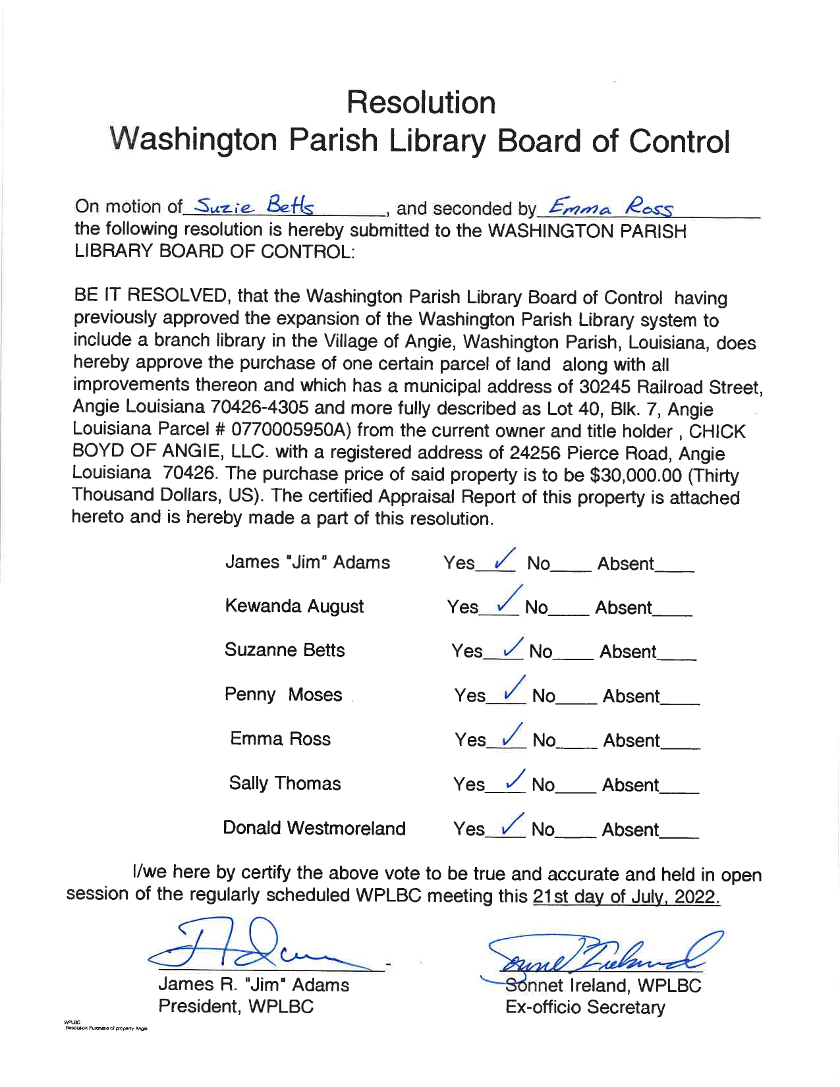

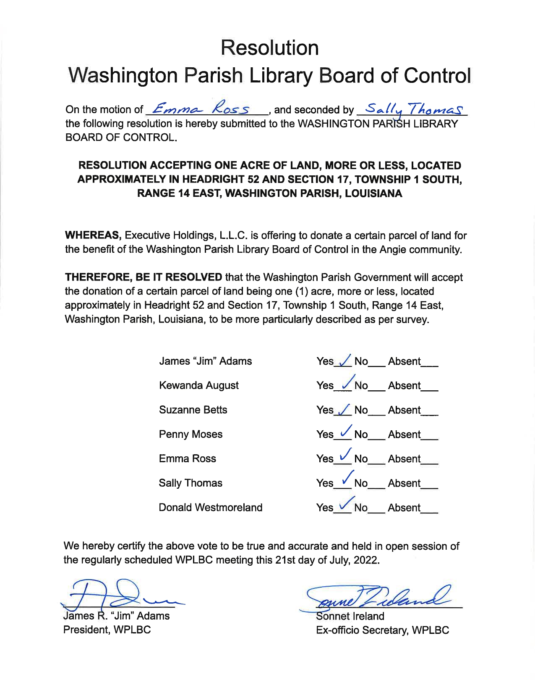

Washington Parish Library
Library Board of Control
Franklinton Branch
Thursday, August 18, 2022 6pm
Meeting Minutes

- Call to Order by Mr. Jim Adams at 6:04pm
- Roll Call by Mrs. Sonnet Ireland
Board Members present: Mr. Jim Adams, Mrs. Sally Thomas, Mrs. Suzie Betts, Ms. Penny Moses, and Mr. Donald Westmoreland
Board Members absent: Ms. Kewanda August, and Ms. Emma Ross

- Invocation by Mrs. Thomas
- Pledge of Allegiance by Mr. Westmoreland
- Approval of Minutes
During the review of the minutes, the Board expressed concern over the wording of the Resolution to accept the donation of the train depot property in Angie, which had been passed in the previous meeting on Thursday, July 21, 2022.

A motion was made by Mrs. Thomas to withdraw said Resolution; seconded by Mrs. Betts
Mr. Jim Adams: Yes

Mrs. Sally Thomas: Yes
Ms. Kewanda August: Absent
Mrs. Suzie Betts: Yes

Ms. Penny Moses: Yes
Ms. Emma Ross: Absent
Mr. Donald Westmoreland: Yes

Motion passed.

On the motion of Mrs. Betts, and seconded by Mrs. Thomas the following resolution is hereby submitted to the Washington Parish Library Board of Control.
Resolution accepting one acre of land, more or less, located approximately in Headright 52 and Section 17, Township 1 South, Range 14 East, Washington Parish, Louisiana.
WHEREAS, Executive Holdings, L.L.C. is offering to donate a certain parcel of land for the benefit of the Washington Parish Library Board of Control in the Angie community.
THEREFORE, BE IT RESOLVED that the Washington Parish Library Board of Control will accept the donation of a certain parcel of land being one (1) acre, more or less, located approximately in Headright 52 and Section 17, Township 1 South, Range 14 East, Washington Parish, Louisiana, to be more particularly described as per survey.
Mr. Jim Adams: Yes

Mrs. Sally Thomas: Yes
Ms. Kewanda August: Absent
Mrs. Suzie Betts: Yes

Ms. Penny Moses: Yes
Ms. Emma Ross: Absent
Mr. Donald Westmoreland: Yes

Motion passed.

A motion was made by Ms. Moses to accept the July 21, 2022 minutes as written; seconded by Mr. Westmoreland. All present Board Members agreed. Motion passed.

- Director’s Report (see attached)
[Director’s Note: There was an error in the reporting of the number of Events and Attendees at the Bogalusa Branch for the month of May. This error has been corrected.]
Mr. Adams asked Mrs. Ireland if the Library ever received the additional money from the insurance agency. Mrs. Ireland said the Library had not, which was verified by Mrs. Etta Magee, Assistant Director.

- Bulletins and Correspondence
Mrs. Ireland relayed that the State Library has offered Trustee Training to the Washington Parish
Library Board of Control. Having a new Trustee on the Board makes it a good time to have the
State Library refresh everyone. She will be reaching out to the Board members over the next week or so to find dates that might work for this.

- Unfinished Business
  - Library at the Washington Parish Fair
Mrs. Ireland would like the Board to consider closing the Library completely for the Thursday and Friday of the Washington Parish Fair in order to focus on having Library representation at the Fair instead. The State Archives will have a table that they are willing to share with the Library. Depending on how this outreach attempt goes, the Library could work on having our own table for 2023.
Mrs. Thomas mentioned the possibility that people may want to use the Library instead of going to the Fair. Mrs. Betts pointed out that it’s almost impossible to get anywhere in Franklinton during the Fair. Ms. Moses said she expected there was likely low foot traffic at the Library during the Fair except for the occasional stop to use the restroom. Mr. Adams voiced his support for what he thought would be a great opportunity for outreach. Concern was expressed by a member of the public, Mr. Perry Tally, about the number of holidays the Library had. Mrs. Ireland pointed out that this would not be two additional holiday days (16 hours) but would instead change two half-day holidays to full-day holidays (adding 8 additional holiday hours). Mrs. Ireland explained that anyone who worked the Fair would get comp time in that pay period.

A motion was made by Mrs. Betts to make Thursday, October 20th and Friday,
October 21st full holidays to allow for Library outreach; seconded by Mr. Westmoreland.
Mr. Jim Adams: Yes

Mrs. Sally Thomas: Yes
Ms. Kewanda August: Absent
Mrs. Suzie Betts: Yes
Ms. Penny Moses: Yes
Ms. Emma Ross: Absent
Mr. Donald Westmoreland: Yes

Motion passed.

  - Christmas Holiday adjustment
Mrs. Ireland noticed a problem with the 2022 Holiday Schedule for the Library. The Policy Manual states that Library staff get three holiday days for Christmas. When the 2022 schedule was written in 2020, it did not take into account that Christmas was on a Sunday. As a result, the holidays on the schedule for the Library are Saturday, December 24th, Sunday, December 25th, and Monday, December 26th. Since the Library is already closed on Sundays and only two full-time staff work on Saturdays, most of the staff will only have Monday, December 26th as a holiday. If the Board does not wish to give three work days as holidays, Mrs. Ireland offered the option of being closed for Veteran’s Day like many other Libraries. Mrs. Ireland was anxious to get an answer from the Board so the Library could move forward with planning events.
A member of the public, Mr. Perry Tally, mentioned the option of changing the policy so this wouldn’t happen in future years. Mrs. Ireland acknowledged that the policy could be changed in the future, but she also expressed reservations about making a change for something that only happens every six or seven years.
A motion was made by Mrs. Thomas to close the Library for Christmas holiday from Thursday, December 22nd through Monday, December 26th, reopening again on Tuesday, December 27th in order to give the staff three Christmas paid holiday days per policy; seconded by Ms. Moses.
Mr. Jim Adams: Yes

Mrs. Sally Thomas: Yes
Ms. Kewanda August: Absent
Mrs. Suzie Betts: Yes

Ms. Penny Moses: Yes
Ms. Emma Ross: Absent
Mr. Donald Westmoreland: Yes

Motion passed.

  - Part-timer Benefits
Mrs. Ireland again brought up the issue of the part-timers benefits. After a meeting with Mrs. Donna Graham and Mrs. Kristen Spears on Tuesday, August 16th, Mrs. Ireland and Mrs. Etta Magee learned that there were concerns about part-timers being owed retirement benefits if they worked over 27 hours a week too frequently. Originally, the Library had been told that part-timers would only be owed retirement benefits if the average of their time at the end of the year was 28 hours per week or more. This new issue further complicates the issues with allowing part-timers to make up time. Mrs. Ireland argues that it would be less expensive long term and less complicated to return the benefits back to the part-timers. Mrs. Ireland also shared that, in that meeting, Mrs. Graham stated that the Library can have whatever policies they want with regards to giving part-timers benefits, but that the Parish would not track that time–the Library would have to internally track the time off that part-timers earn and use. Mr. Adams expressed concern since a Parish lawyer had asked us not to move forward on this issue. Mrs. Ireland suggested that she and Mr. Adams meet with the lawyer before the next meeting to get an answer.
Several members of the public at the meeting expressed frustration that this issue had not been resolved yet. Mr. Perry Tally offered to meet with Mr. Adams and Mrs. Ireland to get a better idea of what options might exist for the Library.
- New Business
  - Policy Updates
    - Hotspot checkout policy updates
A motion was made by Mr. Westmoreland to implement the Hotspot Checkout Policy as amended in the meeting to include renewals; seconded by Mrs. Betts.
Mr. Jim Adams: Yes

Mrs. Sally Thomas: Yes
Ms. Kewanda August: Absent
Mrs. Suzie Betts: Yes

Ms. Penny Moses: Yes
Ms. Emma Ross: Absent
Mr. Donald Westmoreland: Yes

Motion passed.
- Public Comment
Mr. Perry Tally, Chairman of the Washington Parish Watermelon, Fruit, and Vegetable Association, which is in the process of bringing back the Washington Parish Watermelon Festival. The last one in Franklinton was in 2003. This will be a community effort, and he is seeking community partners. The Association is also looking for two Executive Board Members–a Secretary and a Treasurer. Mrs. Ireland mentioned that the Library has a Seed Library; she thinks there would be some wonderful opportunities for Library programming around watermelon seeds when the time comes. The Association has been meeting on the first Tuesday of the month at 6pm at the 4-H Building. Meetings will likely increase as they get closer to the date of the Watermelon Festival–they are currently hoping to hold it the weekend after the Fourth of July.
Mr. Tally wants to commend the Director and the Board. He has heard many good things about the Library in the community from the public. He shared that people have been talking about how things have been improving with the Library.
Mr. Alan Gray commented on the story about the Library staff saving that kitten, and he said that it’s brought up some very heartwarming feelings and goodwill from the public towards the Library and its staff.

- Adjournment
A motion was made to adjourn by Ms. Moses and seconded by Mrs. Thomas. All Board Members agreed. Motion passed. Meeting adjourned at 7:57pm.

The next meeting is scheduled for 5:30pm Thursday, September 15, 2022 at the Bogalusa Branch.
Washington Parish Library
Director’s Report
Thursday, August 18, 2022

Library Activity

May 2022
Branch | Programs / Attendance | Checkouts | Reference | Computer Use | Wifi | Patron Count
Bogalusa | 9 / 325* | 1333 | 14 | 566 | 1005 | 2484
Franklinton | 17 / 254 | 1673 | 22 | 319 | 2274 | 1845
Enon | 5 / 249 | 508 | - | 50 | 120 | 329
Thomas | 4 / 115 | 295 | - | 11 | 870 | 196
Total | 35 / 943* | 3,809 | 36 | 946 | 4,269 | 4,854

June 2022
Branch | Programs / Attendance | Checkouts | Reference | Computer Use | Wifi | Patron Count
Bogalusa | 23 / 981 | 1501 | 82 | 593 | 1456 | 2938
Franklinton | 61 / 944 | 1940 | 26 | 418 | 1517 | 2029
Enon | 16 / 937 | 948 | - | 65 | 131 | 950
Thomas | 6 / 372 | 298 | - | 17 | 584 | 292
Total | 106 / 3,234 | 4,687 | 108 | 1,093 | 3,688 | 6,209

July 2022
Branch | Programs / Attendance | Checkouts | Reference | Computer Use | Wifi | Patron Count
Bogalusa | 17 / 488 | 1376 | 49 | 519 | 2756 | 2478
Franklinton | 37 / 457 | 1469 | 14 | 418 | 2319 | 1890
Enon | 3 / 202 | 551 | - | 58 | 303 | 340
Thomas | 2 / 50 | 225 | - | 24 | 757 | 170
Total | 59 / 1,197 | 3,621 | 63 | 1,019 | 6,135 | 4,878

Totals as of August 1, 2022
 | Events / Attendance | Checkouts | Reference | Computer Use | Wifi | Patron Count
Jan | 31 / 1,080 | 2,197 | 37 | 980 | 11,362 | 3,325
Feb | 47 / 1,539 | 2,298 | 20 | 914 | 1,926 | 3,841
Mar | 47 / 1,146 | 2,784 | 84 | 1,002 | 2,146 | 4,365
Apr | 44 / 1,649 | 3,180 | 25 | 946 | 5,503 | 4,117
May | 35 / 943* | 3,809 | 36 | 946 | 4,269 | 4,854
Jun | 106 / 3,234 | 4,687 | 108 | 1,093 | 3,688 | 6,209
Jul | 59 / 1,197 | 3,621 | 63 | 1,019 | 6,135 | 4,878
YTD | 369 / 10,788* | 22,576 | 373 | 6,900 | 35,029 | 31,589

In addition to all of these wonderful in-person programs, we have also started offering virtual programs through various partnerships. In July, we hosted two virtual author talks with a total of 48 views for that month. We also offer virtual programs on financial planning, but we are unable to get specific numbers for those programs.

Library Staff

Professional Development
The four branch managers, Lahoma Dawson, Bonnie Dier, Winola Holliday, and Marsha Miley, have started the Supervision and Management course through the State Library.

I attended the following:
HR Crash Course (American Library Association)
Trauma in the Library webinar
LOUIS Focus Group: Supporting School Librarians as OER Instructional Leaders in Louisiana Dual Enrollment (DE) (June 3rd)
Universal Data’s Disaster Recovery Readiness
Louisiana Library Association Conference (July 6th-9th)
Effective Health Communication and Health Literacy webinar
State Library Orientation (July 28th)
Project Outcome 101 webinar
New Director’s Bootcamp (August 11th-12th)

Outreach
I presented on the Library (and our services) at a Bogalusa Rotary Club meeting on May 24th. The meeting included Bogalusa Strong, FOCUS Franklinton, & WPCC.

Updates

We have started adding Teen Programs to our schedules. Both Franklinton and Bogalusa have had a very successful start to that endeavour. We are continuing to add programming, courtesy of the donation from the Lions Club. We will also be adding adult programming this month with a visit and signing from local author M. Scott Smallwood at the Franklinton Branch. Next month, he will visit the other branches. In September, we will also start adding some adult programming each month. We have a program scheduled for Franklinton and Bogalusa for September, October, and November.

We recently learned that our application for the PLA Digital Literacy Workshop Incentive with AT&T has been accepted. We asked for $7,000 to set up technology workshops across the parish. We are very excited about what this means, particularly for our communities like Mt. Hermon, Angie, and Pine. I will be attending an introductory webinar next week, and the workshops will begin in October.

We also were accepted as an ARSL (Association of Rural and Small Libraries) and Color Health Testing Partner as part of a program with the Centers for Disease Control and Prevention. The CDC’s Increasing Community Access To Testing (ICATT) program is designed to expand access to free COVID-19 testing. We currently have this set up at the Bogalusa Branch, and we will be setting up another site at the Franklinton Branch.

We are working with the Parish to continue setting up Wi-Fi routers throughout the community. Next week, I will be reaching out to the businesses that were interested in participating to verify that they are still interested.

We’re starting a newsletter using a program called Sendinblue, which is free at our current level. It is a company that follows the strict privacy laws of the EU, so we are certain it will protect our patrons’ privacy.

I attended the Washington Parish Council on Monday, May 23rd and the Franklinton City Council meeting on Tuesday, May 24th to talk about our Summer Reading Program and Fine Forgiveness. I was also honored at the August 8th Parish Council meeting for being awarded the Public Librarian of the Year by the Louisiana Library Association.

Attending the New Director’s Bootcamp this month was very enlightening. The sessions covered labor laws such as FMLA, ADA, and harassment laws, bid law and purchasing, record retention, library laws in Louisiana, policies and procedures in libraries, addressing challenges to materials, and maintaining and renovating/building facilities and buildings. It was a very informative two days.

I have been invited to attend Library Journal Directors’ Summit in December. The summit itself is free, so I would just need airfare and a hotel room. This summit will cover issues in libraries such as diversity and inclusion, supporting frontline staff, and addressing censorship.

In the News
“Washington Parish Library Staff Saves Kitten Trapped in Plastic.” The Daily News. August 12, 2022. https://www.bogalusadailynews.com/2022/08/12/washington-parish-library-staff-saves-kitten-trapped-in-plastic/
“Washington Parish Library Staff Saves Kitten Trapped in Plastic.” Mt. Hermon Web TV. August 9, 2022. https://www.mthermonwebtv.com/2022/08/washington-parish-library-staff-saves.html
“Penny Moses Joins Washington Parish Library Board.” The Era-Leader. August 8, 2022. https://www.era-leader.com/local-content-top-stories/penny-moses-joins-washington-parish-library-board
“Moses Appointed to Library Board, Board Honors Late Jackson.” The Daily News. August 5, 2022. https://www.bogalusadailynews.com/2022/08/05/moses-appointed-to-library-board-board-honors-late-jackson/
“Penny Moses Appointed to Library Board; Library Board Honors Mrs. Luella Jackson.” Mt. Hermon Web TV. August 4, 2022. https://www.mthermonwebtv.com/2022/08/penny-moses-appointed-to-library-board.html
“Free COVID-19 Tests Now at Library.” The Daily News. July 29, 2022. https://www.bogalusadailynews.com/2022/07/29/free-covid-19-tests-now-at-library/
“Luella Jackson.” The Daily News. July 29, 2022. https://www.bogalusadailynews.com/2022/07/29/luella-jackson/
“Free COVID Testing at the Bogalusa Library.” Mt. Hermon Web TV. July 28, 2022. https://www.mthermonwebtv.com/2022/07/free-covid-testing-at-bogalusa-library.html
“Washington Parish Library Director is State Librarian of the Year.” The Era-Leader. July 21, 2022. https://www.era-leader.com/local-content-top-stories/washington-parish-library-director-state-librarian-year
“Washington Parish Library Director Named Public Librarian of the Year.” Mt. Hermon Web TV. July 13, 2022. https://www.mthermonwebtv.com/2022/07/washington-parish-library-director.html
“Parish Library Director Named State’s Librarian of the Year.” The Daily News. July 13, 2022. https://www.bogalusadailynews.com/2022/07/13/parish-library-director-named-states-librarian-of-the-year/
“Washington Parish Library Director is Librarian of the Year.” The Era-Leader. July 13, 2022. https://www.era-leader.com/local-content-top-stories/washington-parish-library-director-librarian-year
“Virtual Program Brings Noted Authors to Washington Parish Library.” The Era-Leader. July 7, 2022. https://www.era-leader.com/local-content-top-stories/virtual-program-brings-noted-authors-washington-parish-library
“Luelle M. Jackson.” Mt. Hermon Web TV. July 6, 2022. https://www.mthermonwebtv.com/2022/07/obituary_26.html
“Washington Parish Library Brings Author Talks Home–Virtually.” The Bogalusa Daily. July 5, 2022. https://www.bogalusadailynews.com/2022/07/05/washington-parish-library-brings-author-talks-home-virtually/
“Washington Parish Library Brings Author Talks Home–Virtually!” Mt. Hermon Web TV. July 1, 2022. https://www.mthermonwebtv.com/2022/07/washington-parish-library-brings-author.html
“Enon Library Winners.” The Era-Leader. June 23, 2022. https://www.era-leader.com/local-content-state-sports-top-stories/enon-library-winners
“Franklinton Firefighters at Library for Summer Reading Program.” The Era-Leader. June 16, 2022. https://www.era-leader.com/local-content-top-stories/franklinton-firefighters-library-summer-reading-program
“A Visit from an Author (and an Illustrator!)” The Daily News. June 14, 2022. https://www.bogalusadailynews.com/2022/06/14/a-visit-from-an-author-and-an-illustrator/
“Give Back in Franklinton: Winn-Dixie Community Bag Program Aims to Eliminate Waste, Donate to Good Causes.” The Daily News. June 10, 2022. https://www.bogalusadailynews.com/2022/06/10/give-back-in-franklinton-winn-dixie-community-bag-program-aims-to-eliminate-waste-donate-to-good-causes/
“Summer Reading Program at Enon Library.” The Era-Leader. June 9, 2022. https://www.era-leader.com/communities-local-content-top-stories/summer-reading-program-enon-library
“Parish Council Hears about Planned Summer Programs.” The Era-Leader. June 6, 2022. https://www.era-leader.com/local-content-top-stories/parish-council-hears-about-planned-summer-programs
“Give Back in Franklinton: Winn-Dixie Community Bag Program.” Mt. Hermon Web TV. June 1, 2022. https://www.mthermonwebtv.com/2022/06/give-back-in-franklinton-winn-dixie.html
“Booking It: New Library Director Has Experience.” Washington Parish Living. Summer 2022.
“Library’s Summer Reading Program Kicks Off Next Week.” The Daily News. May 27, 2022. https://www.bogalusadailynews.com/2022/05/27/librarys-summer-reading-program-kicks-off-next-week/
“An Ocean of Possibilities at the Washington Parish Library’s Summer Reading Program.” Mt. Hermon Web TV. May 26, 2022. https://www.mthermonwebtv.com/2022/05/an-ocean-of-possibilities-at-washington.html
“An Ocean of Possibilities at the Washington Parish Library’s Summer Reading Program.” The Era-Leader. May 26, 2022. https://www.era-leader.com/entertainment-local-content-top-stories/ocean-possibilities-washington-parish-librarys-summer
“Washington Parish Council Meeting of May 23, 2022.” Mt. Hermon Web TV. May 25, 2022. https://www.mthermonwebtv.com/2022/05/washington-parish-council-meeting-of.html
Finance Report
We have replaced the carpeting in Bogalusa and the tiles in the bathroom and kitchen area for Thomas. We have also purchased a shed for storage at Thomas.
The attached report shows where we stand through July 31, 2022.
I am working on the budget for next year. I’ll be shifting some money into professional development to allow our staff more opportunities for continuing education. I plan to have a more detailed breakdown for the September meeting.

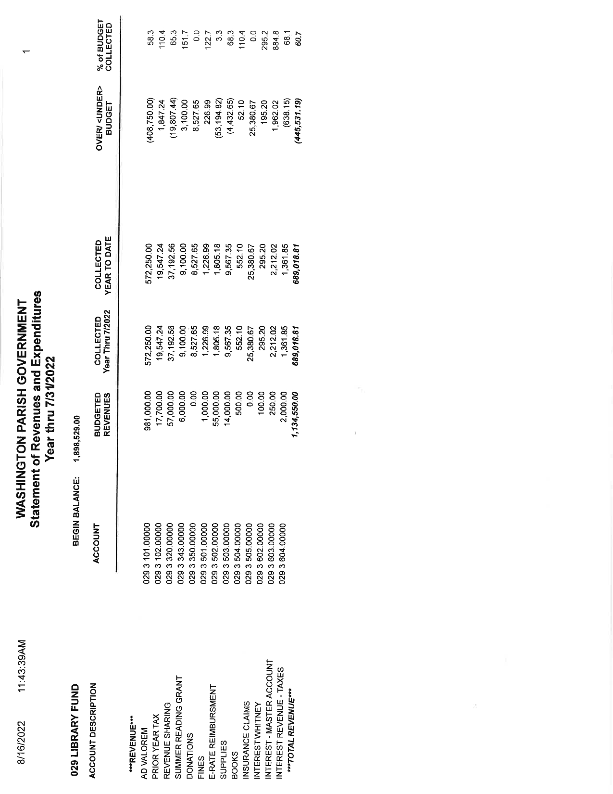

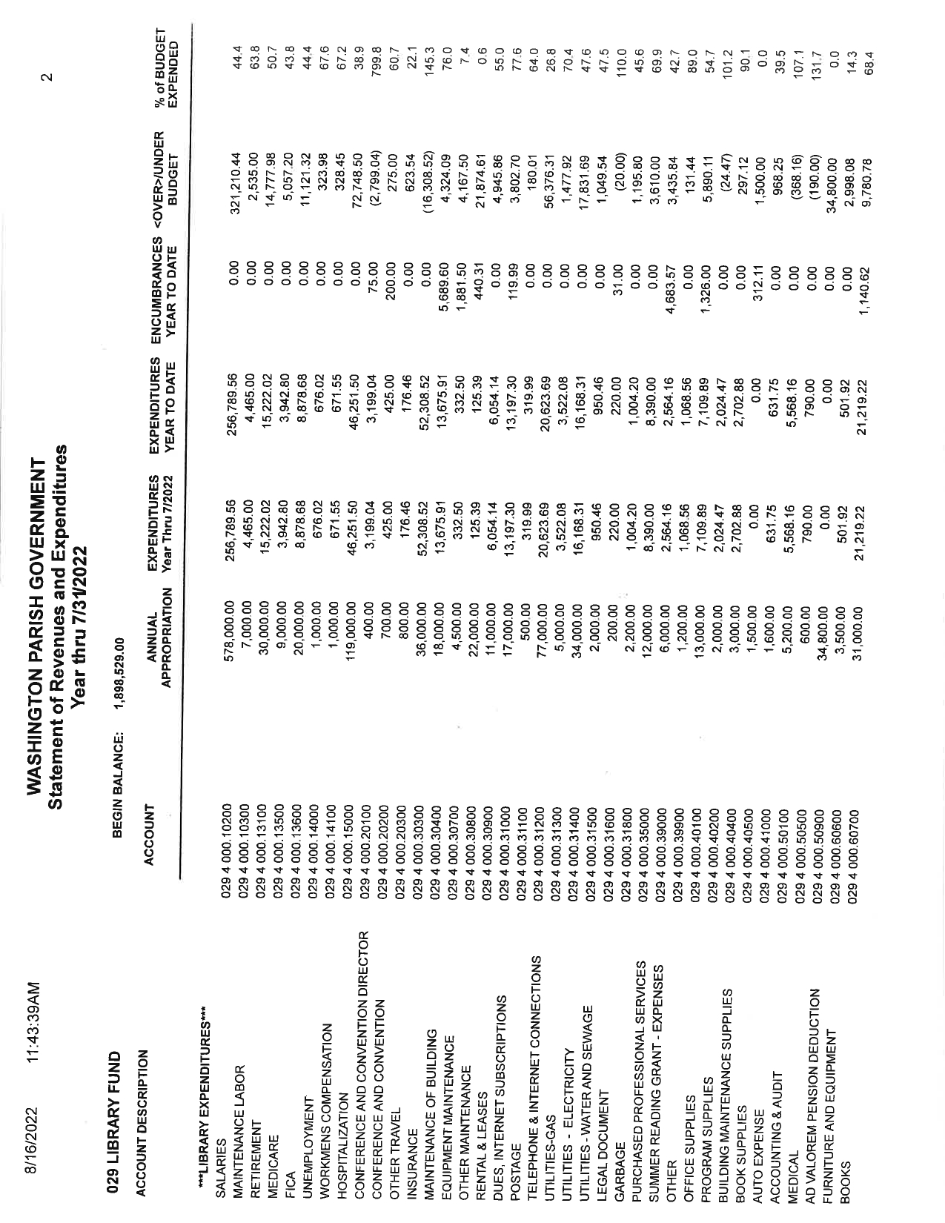

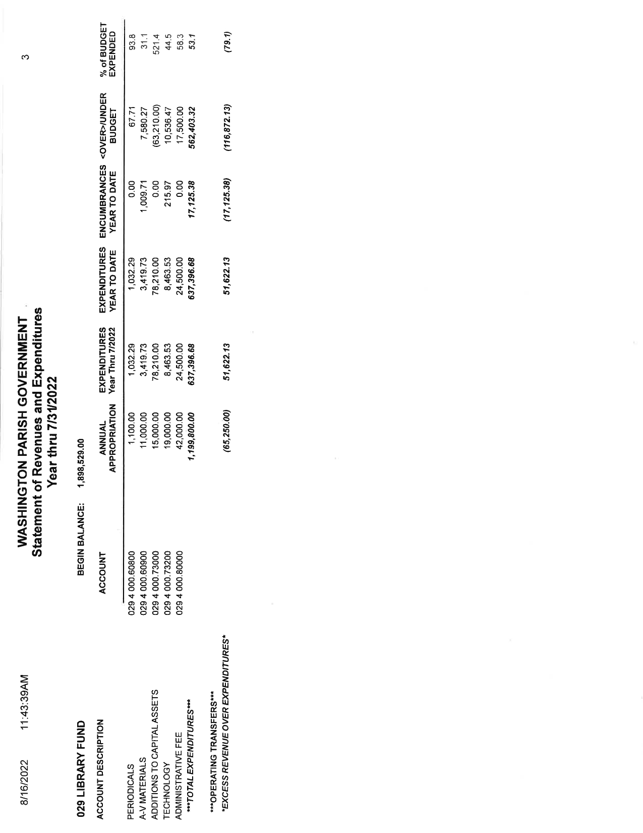
- Call to Order by Mr. Jim Adams at 5:53pm.

- Roll Call by Mrs. Sonnet Ireland.
Board Members present: Mr. Jim Adams, Ms. Kewanda August, Mrs. Suzie Betts, Ms. Penny Moses, and Mr. Donald Westmoreland
Board Members absent: Mrs. Sally Thomas, and Ms. Emma Ross
Guests: Mrs. Donna Graham

- Pledge of Allegiance by Mr. Westmoreland.

- Invocation by Ms. Moses.

- Approval of Minutes
A motion was made by Ms. Moses to accept the August 18, 2022 minutes as written; seconded by Mrs. Betts. All present Board Members agreed. Motion passed.

- Director’s Report (see attached)

- Bulletins/Correspondence - none

- Unfinished Business
  - Part-timer benefits
There have been complications over the past few months with part-timers and making up hours. Originally, since part-timers lost their benefits such as holiday pay and sick leave in 2020, HR had said the Library could allow part-timers to make up time within a pay period or even over a couple of pay periods. Recently, the Parish has discouraged this because of concerns about owing retirement to any part-timer who consistently works more than 27 hours a week. With this in mind, Mrs. Ireland suggested it might be easier and more fiscally responsible to return the benefits that the part-timers lost in March 2020 than to risk having to pay any fees for not adhering to the retirement policy. With this in mind, Mrs. Ireland wrote a temporary policy that would carry the Library through 2022 with regards to holiday pay and part-timers. This policy would offer part-timers pro-rated holiday pay for the Washington Parish Fair, Thanksgiving, and Christmas–the three hardest holidays for staff to make up time for.
Mrs. Donna Graham commented that an issue with returning the benefits part-timers previously were entitled was the lack of such benefits for parish part-time employees.
It was noted that the library depends more heavily on part-timers in order to open and serve the community.
During this segment, Mr. Adams invited Mrs. Graham to speak on recent ARPA funds.

Ms. Moses suggested that the Board look over the compromise brought forth by Mrs. Ireland over the next two months and work to come up with a solution to the problem at the November board meeting.
  - Status update of Angie location
Mrs. Graham had spoken with Mr. Wayne Kuhn, and she believed that the Parish was waiting on the documents from the Library. Mr. Adams has been in contact with Mr. Kuhn and has sent the documents to the Parish. Mrs. Ireland and Mr. Adams have a meeting with Mrs. Graham and Mr. Kuhn on Tuesday, September 20, so this issue should be resolved or clarified then.
  - Status update of Bogalusa covered walkway
The covered walkway at Bogalusa has not yet been fixed. Mr. Adams said he would follow up with the roofing company on that matter.
  - Status update of Franklinton staff parking area
Mrs. Ireland said she recently learned the paving machines are still in the Bogalusa area. Mrs. Graham offered to follow up with Mr. Ken Wheat about the matter.

- New Business
  - Going Fine-Free for Traditional Library Materials
Mrs. Ireland reported on the success of the 6-month Fine Free Pilot Program that the Board approved in the March 17, 2022 meeting. The Library has seen an increase in residents getting library cards, as well as an increase in long-overdue items being returned. As such, Mrs. Ireland requests that the Board make this a permanent policy.
A motion was made by Mr. Westmoreland to accept the updates Mrs. Ireland made to the Overdue Material Policy and adopt a fine-free policy with regard to traditional library materials; seconded by Mrs. Betts.
Mr. Jim Adams: Yes
Mrs. Sally Thomas: Absent
Ms. Kewanda August: Yes
Mrs. Suzie Betts: Yes
Ms. Penny Moses: Yes
Ms. Emma Ross: Absent
Mr. Donald Westmoreland: Yes
Motion passed.
- Public Comment
Questions were asked with regards to who should prepare the budget for the Library. Mrs. Ireland explained that, according to the State Library (the Handbook for Louisiana Public Library Directors), it is the responsibility of the Director to create the budget for the Board to approve. Mr. Adams explained that the budget has been a group effort.

- Adjournment
A motion was made to adjourn by Ms. Moses and seconded by Ms. August. All Board Members agreed. Motion passed. Meeting adjourned at 7:16pm.
The next meeting is scheduled for 5:30pm Thursday, November 17, 2022 at the Franklinton Branch.

Washington Parish Library
Director’s Report
Thursday, September 15, 2022

Library Activity

August 2022
Branch | Programs / Attendance | Checkouts | Reference Questions | Computer Use | Wifi | Patron Count
Bogalusa | 5 / 130 | 1168 | 48 | 661 | 2547 | 2656
Franklinton | 32 / 130 | 1301 | 40 | 516 | 2888 | 2153
Enon | 8 / 210 | 522 | 8 | 52 | 192 | 379
Thomas | 4 / 24 | 252 | - | 9 | 895 | 212
Total | 49 / 494 | 3,243 | 96 | 1,238 | 6,522 | 5,400

Totals as of September 1, 2022
 | Events | Attendance | Checkouts | Reference | Computer Use | Wifi | Patron Count
Jan | 31 | 1,080 | 2,366 | 45 | 980 | 11,362 | 3,325
Feb | 47 | 1,539 | 2,498 | 32 | 914 | 1,926 | 3,841
Mar | 40 | 1,136 | 2,992 | 90 | 1,002 | 2,146 | 4,365
Apr | 42 | 1,642 | 3,180 | 36 | 946 | 5,503 | 4,043
May | 35 | 943 | 3,807 | 48 | 946 | 4,269 | 4,854
Jun | 108 | 3,211 | 4,673 | 119 | 1,093 | 3,688 | 6,209
Jul | 61 | 1,549 | 3,620 | 68 | 1,019 | 6,135 | 4,878
Aug | 49 | 494 | 3,243 | 96 | 1,238 | 6,522 | 5,400
YTD | 413 | 11,594 | 26,379 | 534 | 8,138 | 41,551 | 36,915

Library Staff

Professional Development
The four branch managers, Lahoma Dawson, Bonnie Dier, Winola Holliday, and Marsha Miley, are about halfway through the 10-week Supervision and Management course they are taking with the State Library.

Bonnie Dier attended Fall Adult Favorites webinar by Booklist Publications on August 16th.
Aerial Matthews attended the National Friends of the Library webinar on August 21st, as well as webinars on Grant Writing on August 8th and 18th.
Marian Porter attended Riveting & Page-Turning YA webinar on August 25th.
Sonnet Ireland attended Record Retention training with the Louisiana State Archives on September 14th.

Outreach

Our branches have continued to form and maintain relationships with local schools, such as the Northeshore Charter School, Enon Elementary School, and Thomas Elementary School. Library staff have also established connections with the Bogalusa Chamber of Commerce, the Franklinton Chamber of Commerce, the Franklinton Association of Challenged Citizens, the Washington Parish Council on Aging, the Washington Parish Reading Council, and Head Start. The Library is also working with local and state parks in our area. The Library will be doing outreach at some major events in the area: the 2022 Bogalusa Blues & Heritage Festival (September 23-24), the 2022 Washington Parish Fair (October 19-22), and Bogalusa’s Business on the Block Party (October 28).

Updates

We will be having our first Staff Day since COVID began on Monday, October 10th. As a result, all the branches will be closed that day. Board members are welcome to attend. The day starts at 8:30am at the Franklinton Branch.

In the News

“September is Library Card Sign-Up Month.” The Era-Leader. Thursday, September 8, 2022; Wednesday, August 31, 2022.
https://www.era-leader.com/local-content/september-library-card-sign-month-parish-libraries

“Washington Parish Library Celebrates Library Card Sign-Up Month with Idina Menzel and Cara Mentzel.” The Daily News. Friday, September 2, 2022.
https://www.bogalusadailynews.com/2022/09/02/washington-parish-library-celebrates-library-card-sign-up-month-with-idina-menzel-cara-mentzel/

“September is Library Card Sign-up Month.” Mt. Hermon Web TV. Wednesday, August 31, 2022.
https://www.mthermonwebtv.com/2022/08/september-is-library-card-sign-up-month.html

“Local Author Holding Book Signings at Parish Libraries.” The Daily News. Tuesday, August 23, 2022.
https://www.bogalusadailynews.com/2022/08/23/local-author-holding-book-signings-at-parish-libraries/

“Local Author M. Scott Smallwood at Your Local Library.” Mt. Hermon Web TV. Sunday, August 21, 2022.
https://www.mthermonwebtv.com/2022/08/local-author-m-scott-smallwood-at-your.html

Finance Report
Attachment A is the statement of our revenues and expenditures through August 31, 2022.
Attachment B is the draft of the 2023 budget.

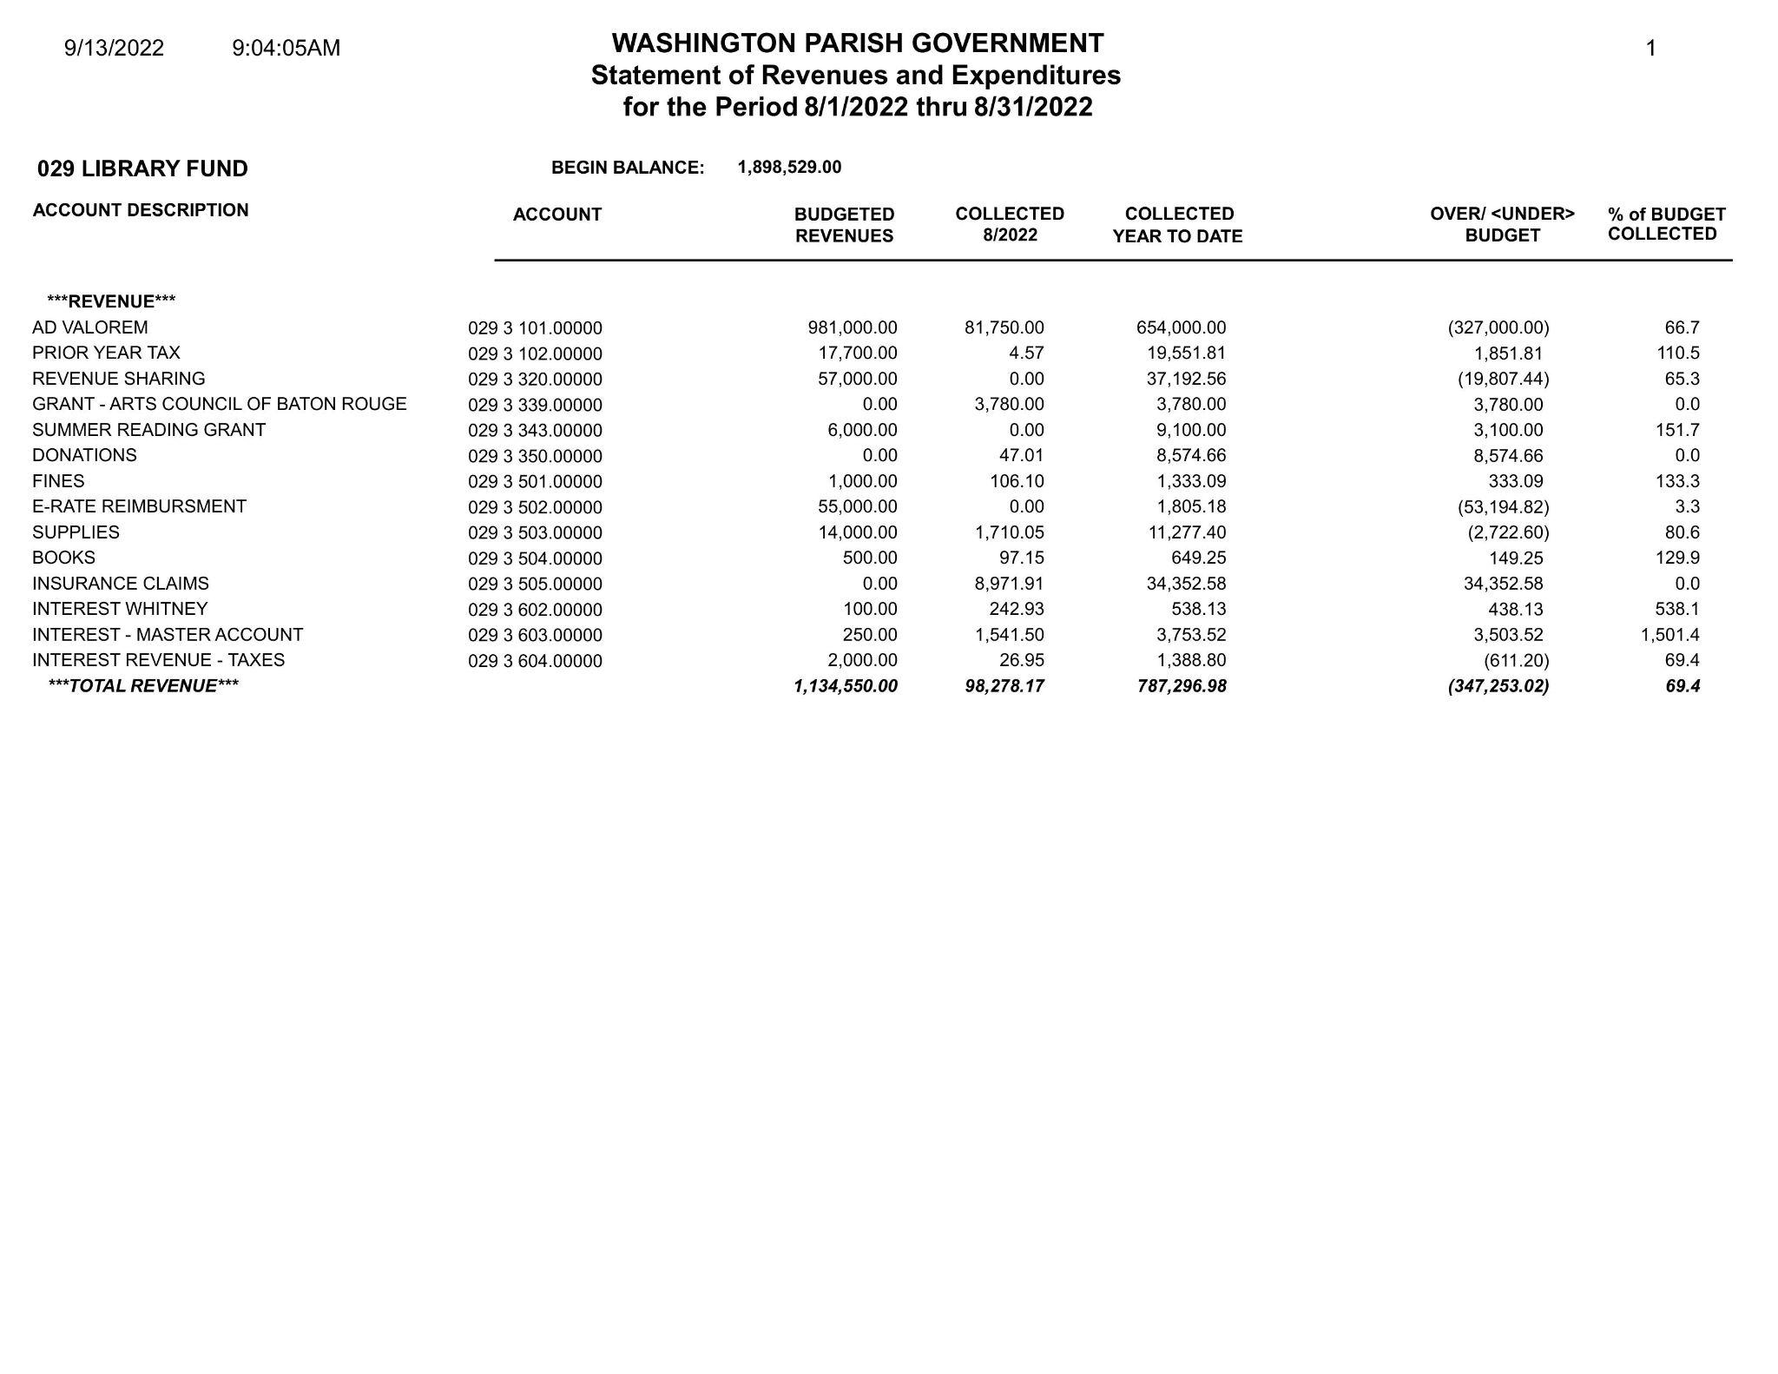

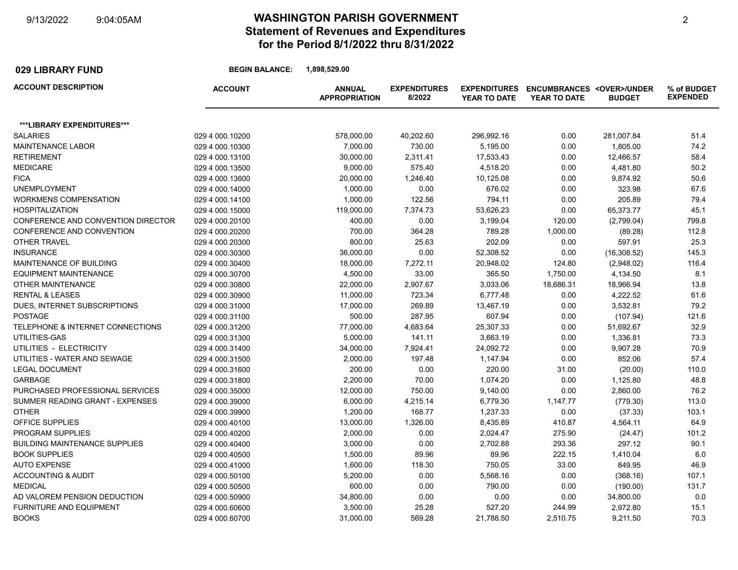

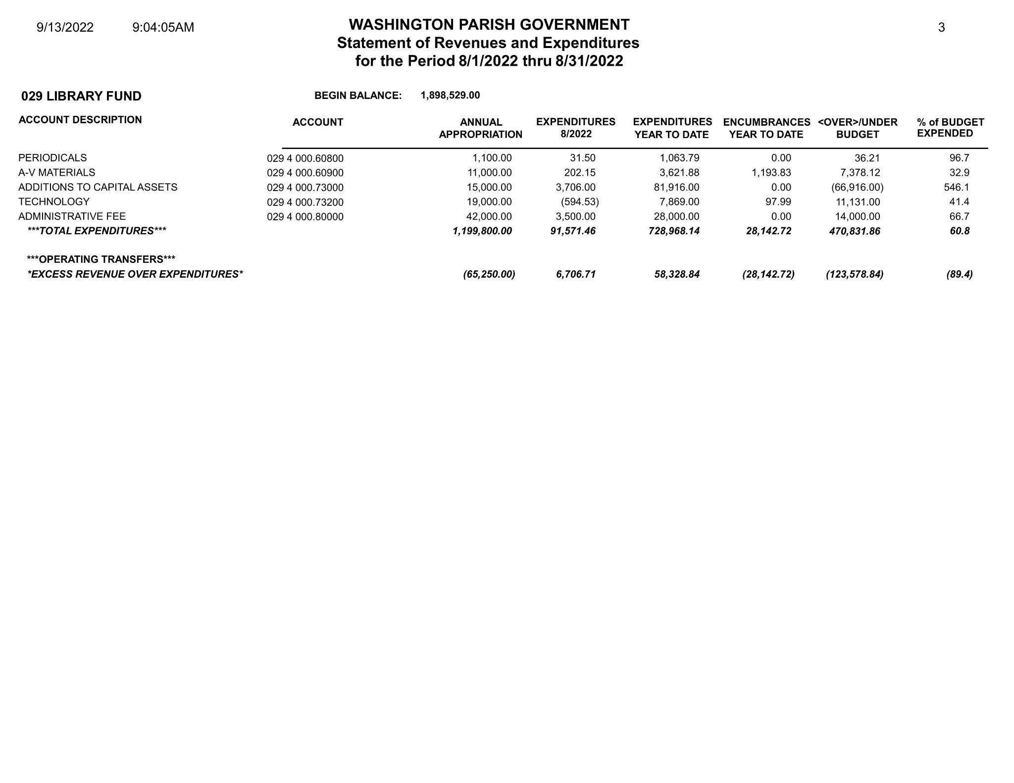

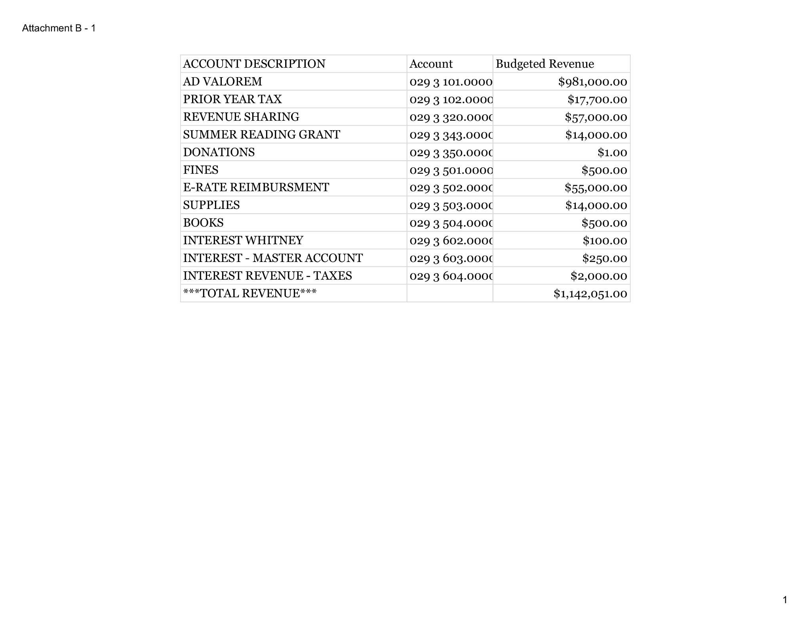

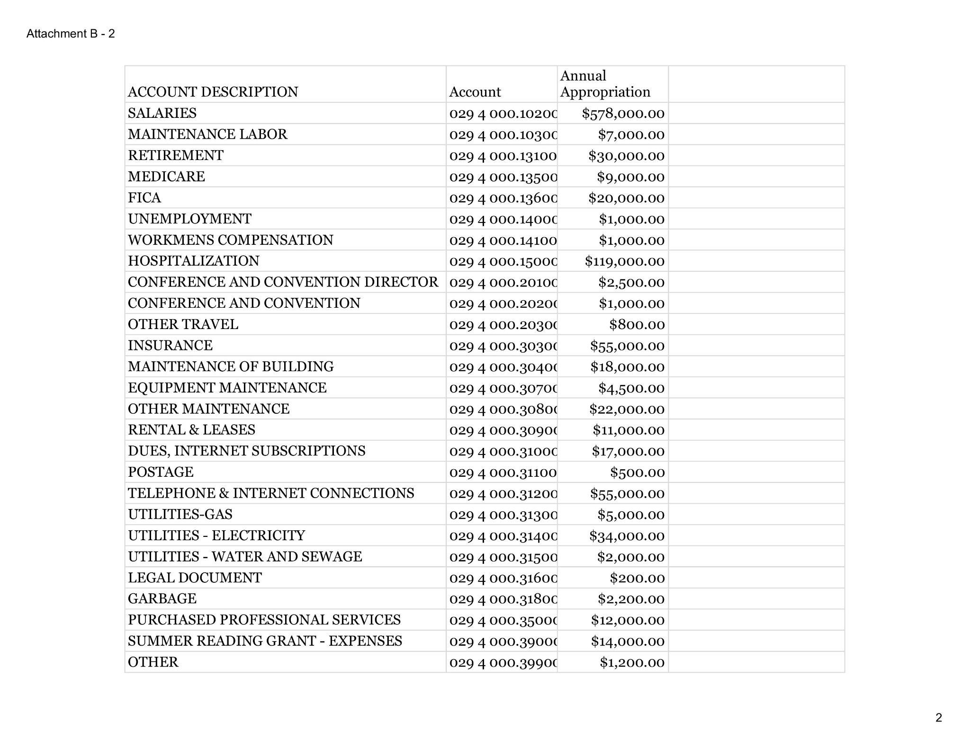

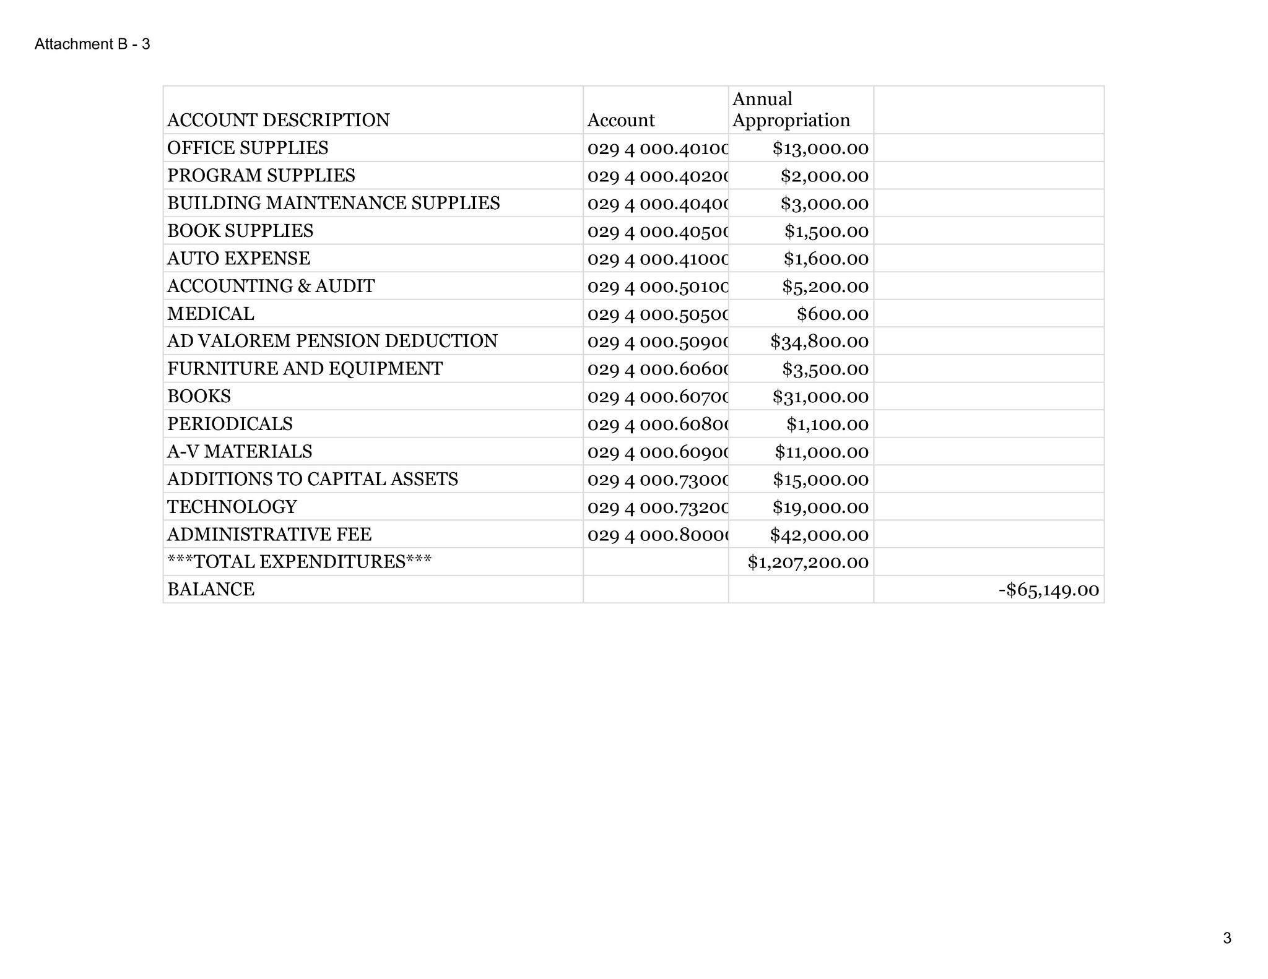

WASHINGTON PARISH LIBRARY
2022 PART-TIMER HOLIDAY PAY POLICY
Whereas the Washington Parish Library relies heavily on its part-time staff for daily functions, and whereas the part-time staff only recently lost benefits that had been promised to them upon being hired by the Washington Parish Library, the Library recognizes it is in our best interest as an organization to grant pro-rated holiday pay for the part-time staff for the rest of 2022 until such time as a solution can be agreed upon by the Library and the Washington Parish Government.

OCTOBER

The Library will be closed for the Washington Parish Fair Holiday the following days:
- Wednesday, October 19th
- Thursday, October 20th
- Friday, October 21st

Part-time library staff shall be paid up to 16 hours for the Washington Parish Fair Holiday.

NOVEMBER

The Library will be closed for the Thanksgiving Holiday the following days:
- Thursday, November 24th
- Friday, November 25th

Part-time library staff shall be paid up to 11 hours for the Thanksgiving Holiday.

DECEMBER

The Library will be closed for the Christmas Holiday the following days:
- Thursday, December 22nd
- Friday, December 23rd
- Monday, December 26th

Part-time library staff shall be paid up to 16 hours for the Christmas Holiday.

WASHINGTON PARISH LIBRARY
OVERDUE MATERIAL POLICY
Whereas libraries exist to enrich their community and strive to provide stress-free and open access to all members of our community, the Washington Parish Library is adopting a fine-free policy with regard to the majority of our checkout materials.
Libraries across the nation have demonstrated that imposing late fees on customers is not an effective deterrent to the return of late materials. Instead, it commonly creates barriers for youth or may cause customer guilt, making library use less likely. We strive to overcome these barriers and increase access to our customers, trusting that our show of good faith will encourage customers to return materials in a timely manner.
Due to their nature and cost, some library items will still incur fines:
- Any technology available for checkout, including but not limited to hotspots, laptops, and tablets, shall accrue a fine of $10 per day (per device) up to a maximum of $100 (per device).
- Interlibrary Loans shall accrue fines based on the lending library’s policies, as the Washington Parish Library cannot make policies governing what happens to materials belonging to other libraries.

REPLACEMENT/DAMAGE COSTS
While fines for traditional library items will not accrue, a replacement cost will be charged once an item is 45 days overdue. Customers with charges for replacement costs will have their account blocked until the item has been paid for or until a payment arrangement has been worked out with the library staff. If the item is returned within one (1) year of the item being charged to the customer, the replacement cost shall be waived.
It is at the discretion of library staff to determine if special circumstances allow replacement fines to be waived if items are returned after these designated periods. Once paid for, materials are the property of the customer and replacement fees will not be refunded.
If an item is late due to being lost or damaged, customers should notify the Library of the item’s status. Library staff will work with customers to extend due dates (when possible and within reason) for missing items. Replacements may be accepted for lost or damaged items at the discretion of the Branch Manager or Administration when:
- The library has been notified within a reasonable amount of time
- The replacement is in “new” condition and matches the description of the item lost/damaged (i.e. hardcover, paperback, large print)
Created: November 2004
Updated: September 2022

Washington Parish Library
Library Board of Control
Bogalusa Branch
Thursday, October 27, 2022, 5:30pm
Special Meeting Minutes

- Call to Order by Mr. Jim Adams at 5:36pm.

- Roll Call by Mrs. Sonnet Ireland.
Board Members present: Mr. Jim Adams, Mrs. Sally Thomas, Ms. Penny Moses, Ms. Emma Ross, and Mr. Donald Westmoreland
Board Members absent: Ms. Kewanda August, and Mrs. Suzie Betts

- Pledge of Allegiance by Ms. Ross.

- Invocation by Mrs. Thomas.

- Approval of Minutes
A motion was made by Ms. Moses to accept the September 15, 2022 minutes as written; seconded by Ms. Ross. All present Board Members agreed. Motion passed.

- New Business
  - 2023 Budget
The Board reviewed the budget. Mrs. Ireland put together a very conservative budget to ensure
the Library would be able to function if interest rates go down.
A motion was made by Ms. Moses to accept the 2023 Budget presented; seconded by Mr. Westmoreland.
Mr. Jim Adams: Yes
Mrs. Sally Thomas: Yes
Ms. Kewanda August: Absent
Mrs. Suzie Betts: Absent
Ms. Penny Moses: Yes
Ms. Emma Ross: Yes
Mr. Donald Westmoreland: Yes
Motion passed.
A motion was made by Mrs. Thomas to add an item to the agenda: the 2022 Budget under VI. New Business as subsection B; seconded by Ms. Ross. All present Board Members agreed. Motion passed.

  - 2022 Budget
The Board reviewed the 2022 Budget line by line. The Library had some extra costs this year with the purchase of Angie and the repair of the Franklinton roof.
A motion was made by Mr. Westmoreland to accept the adjusted 2022 Budget proposal; seconded by Mrs. Thomas.
Mr. Jim Adams: Yes
Mrs. Sally Thomas: Yes
Ms. Kewanda August: Absent
Mrs. Suzie Betts: Absent
Ms. Penny Moses: Yes
Ms. Emma Ross: Yes
Mr. Donald Westmoreland: Yes
Motion passed.
A motion was made by Ms. Ross to add an item to the agenda: the Annual Holiday Staff Luncheon as section VII; seconded by Ms. Moses. All present Board Members agreed. Motion passed.

- Holiday Staff Luncheon
Historically, the Library closes for a couple of hours on a day in December to allow for the Library Staff to gather for a meeting followed by lunch. This year, the Library would like to hold that meeting on Tuesday, December 13th.
A motion was made by Mr. Westmoreland to allow the Library Branches to close at noon on Tuesday, December 13th to allow for the annual holiday staff luncheon, including pay for all staff for the rest of that day; seconded by Mrs. Thomas. All present Board Members agreed. Motion passed.

- Public Comment
Mr. Adams presented every member of the Board with the Employee Handbook. Members of the audience requested how they might be able to see the book; Mr. Adams offered a copy for their use.
Ms. Ross thanked Mrs. Ireland for putting together the budget and thanked her for her hard work for the Library this year.

- Adjournment
A motion was made to adjourn by Mrs. Thomas and seconded by Ms. Ross. All Board Members agreed. Motion passed. Meeting adjourned at 7:03pm.
The next meeting is scheduled for 5:30pm Thursday, November 17, 2022 at the Franklinton Branch.

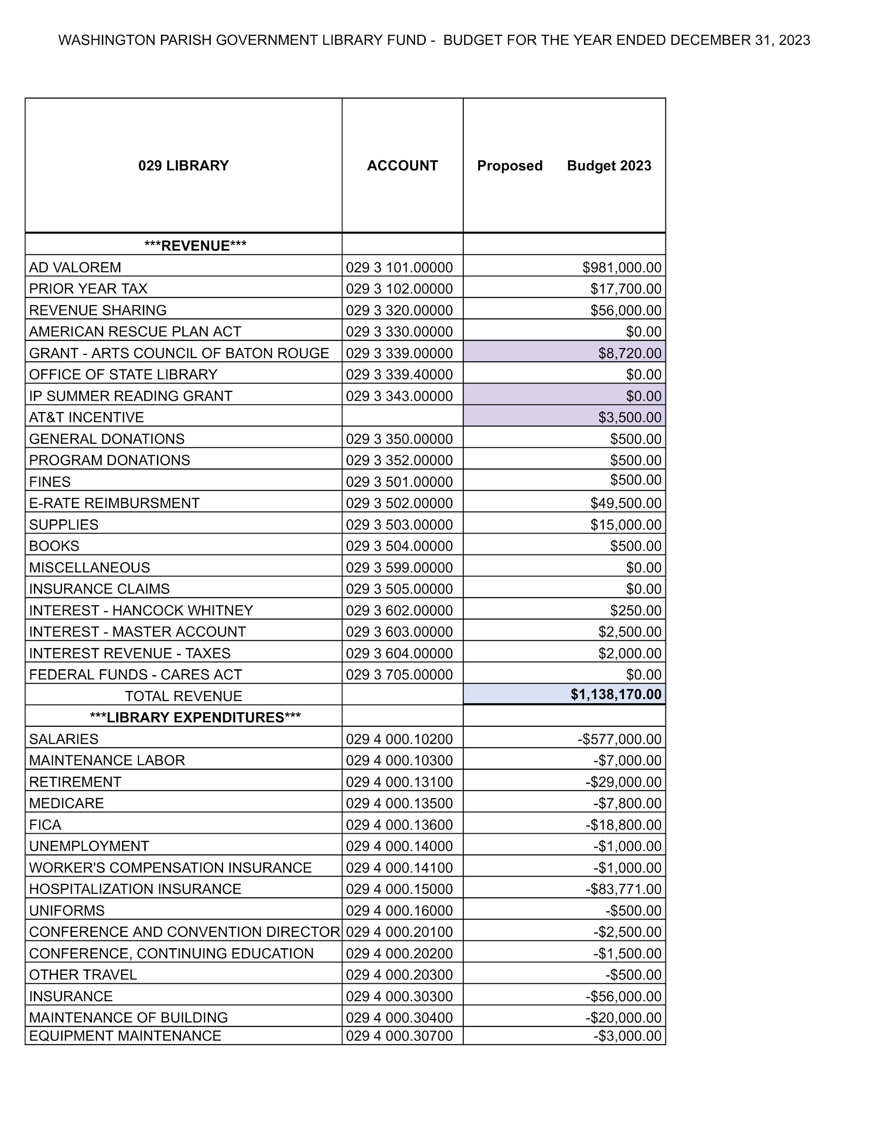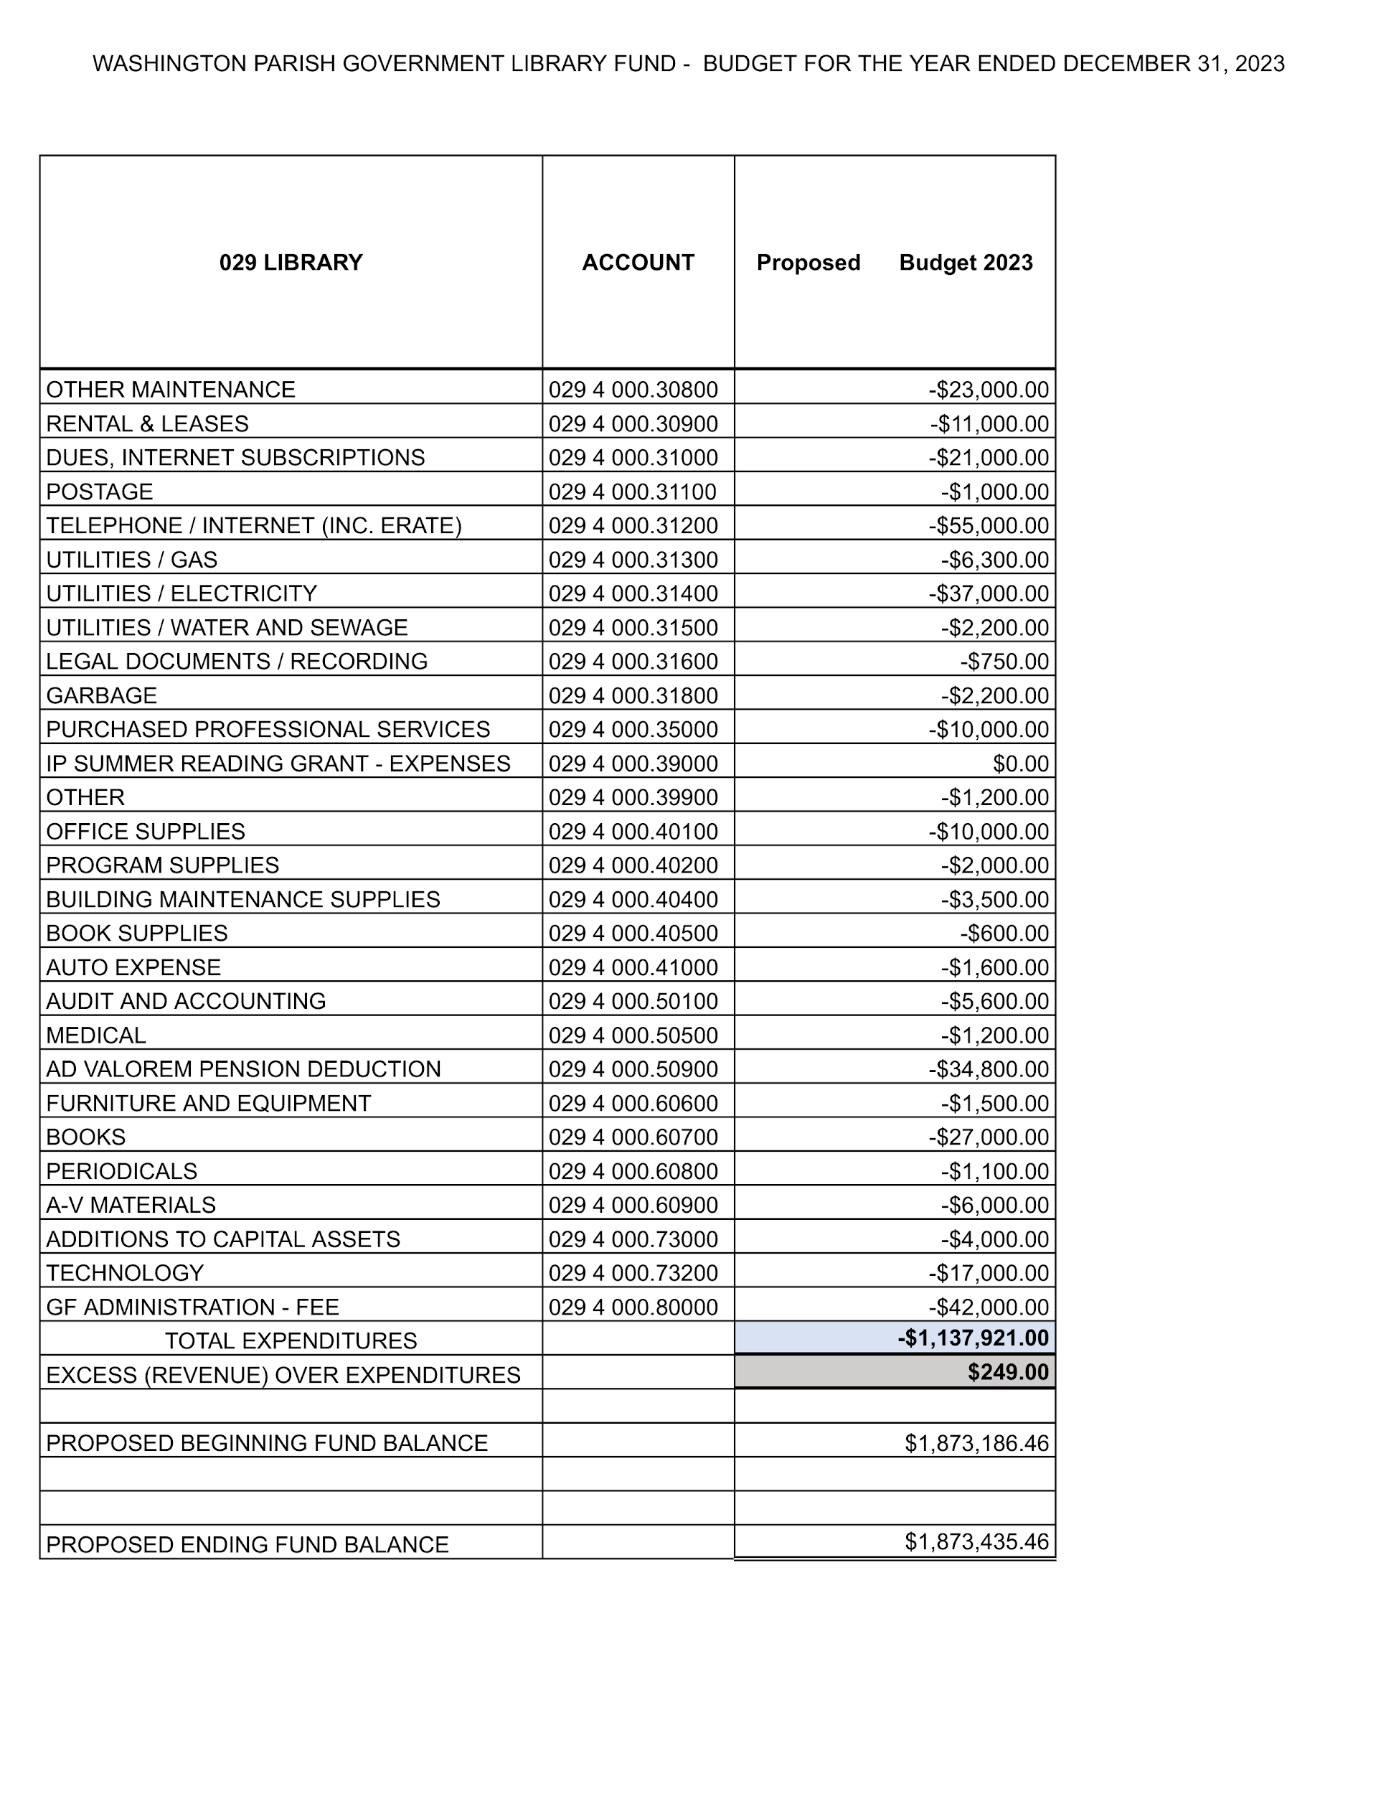

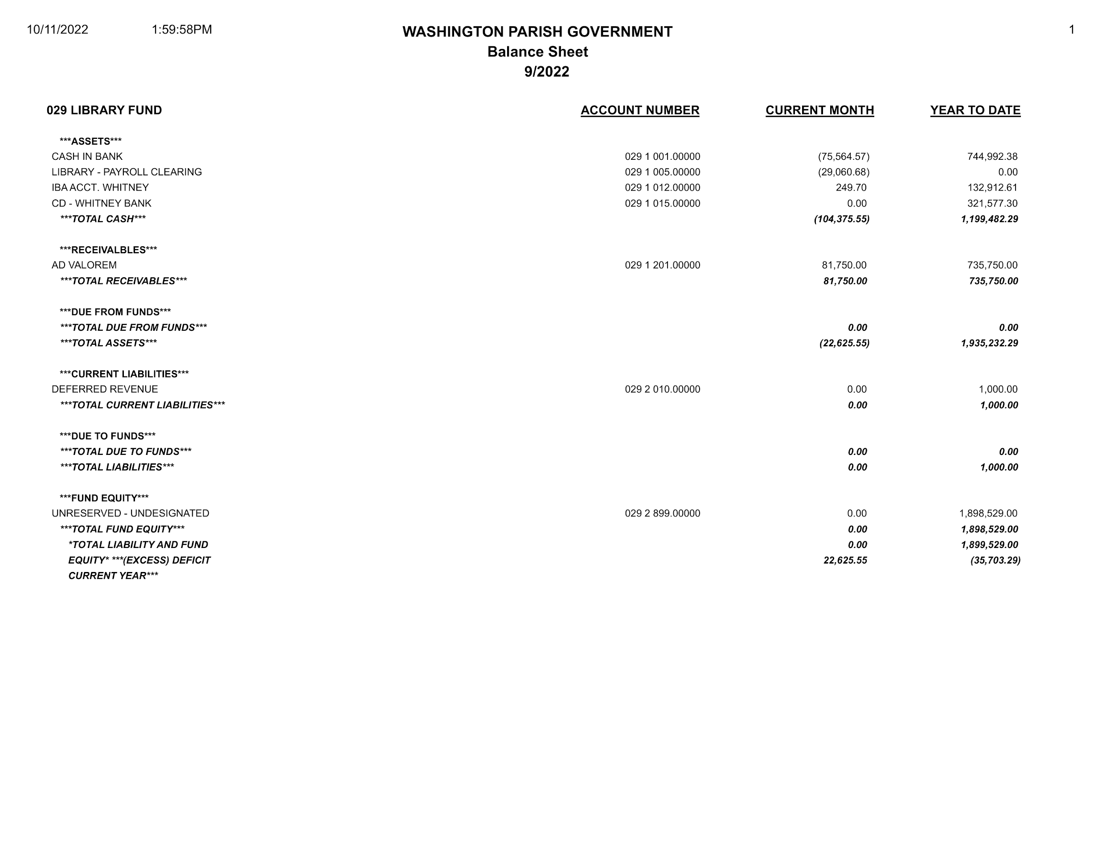
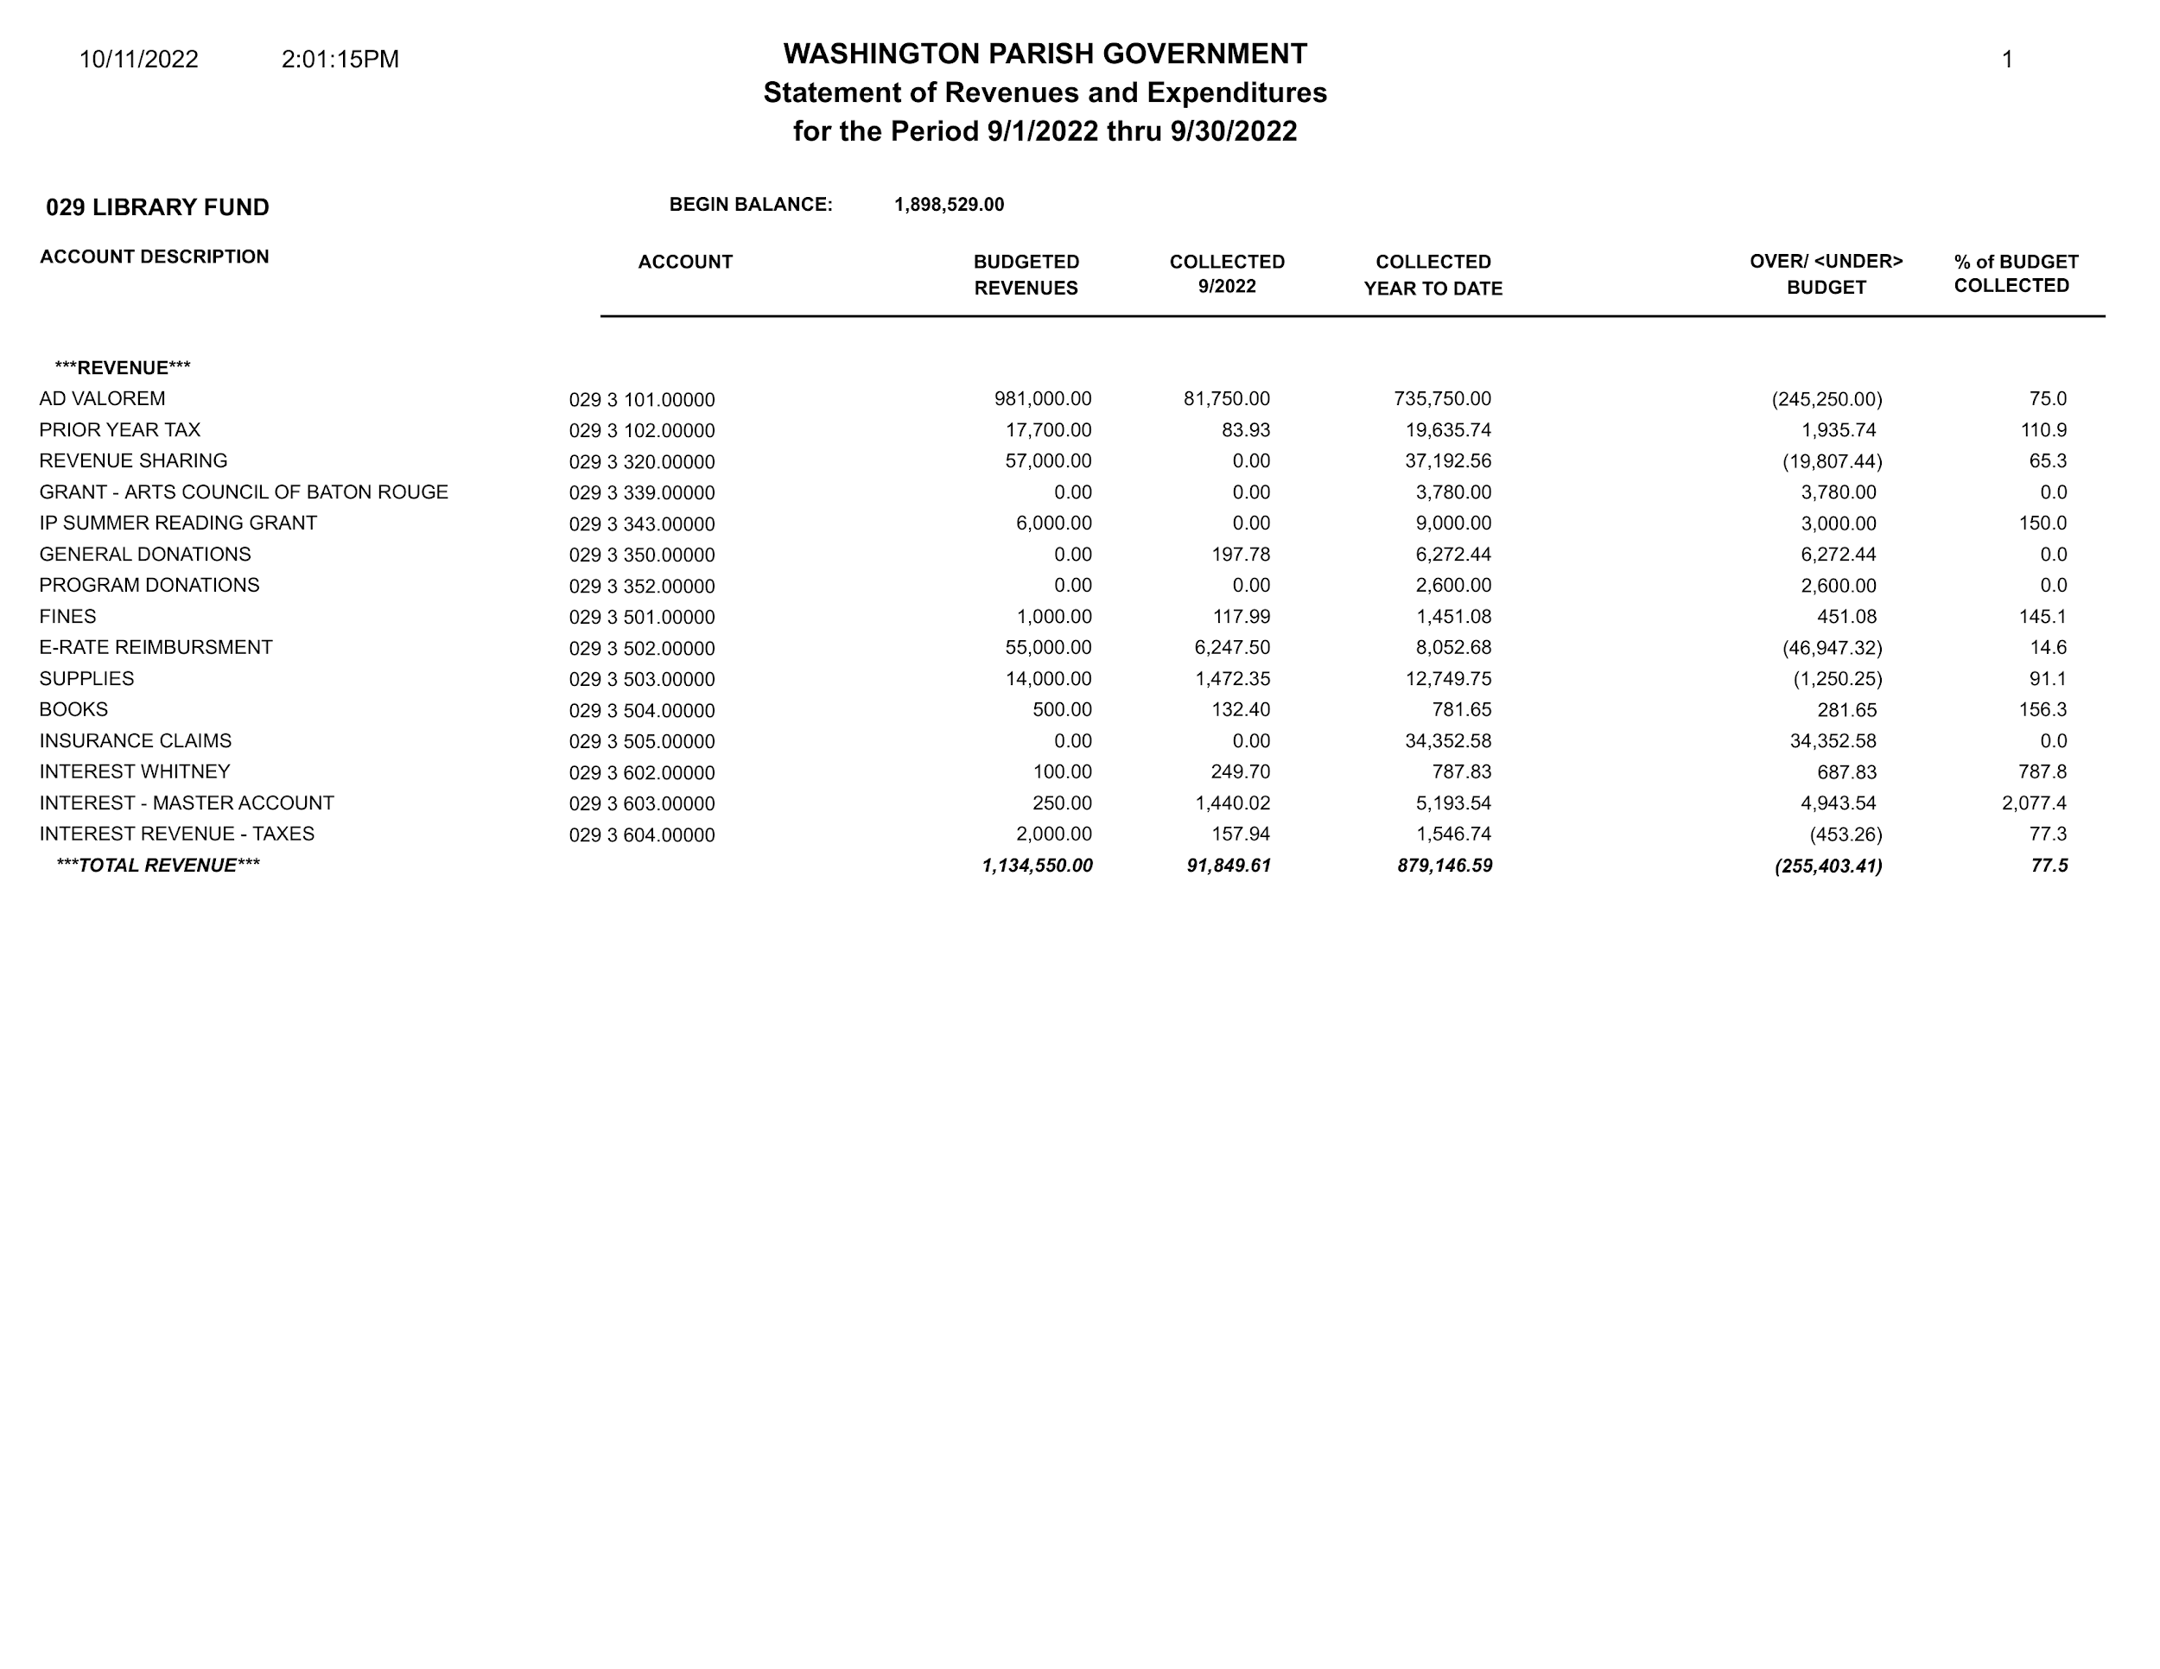

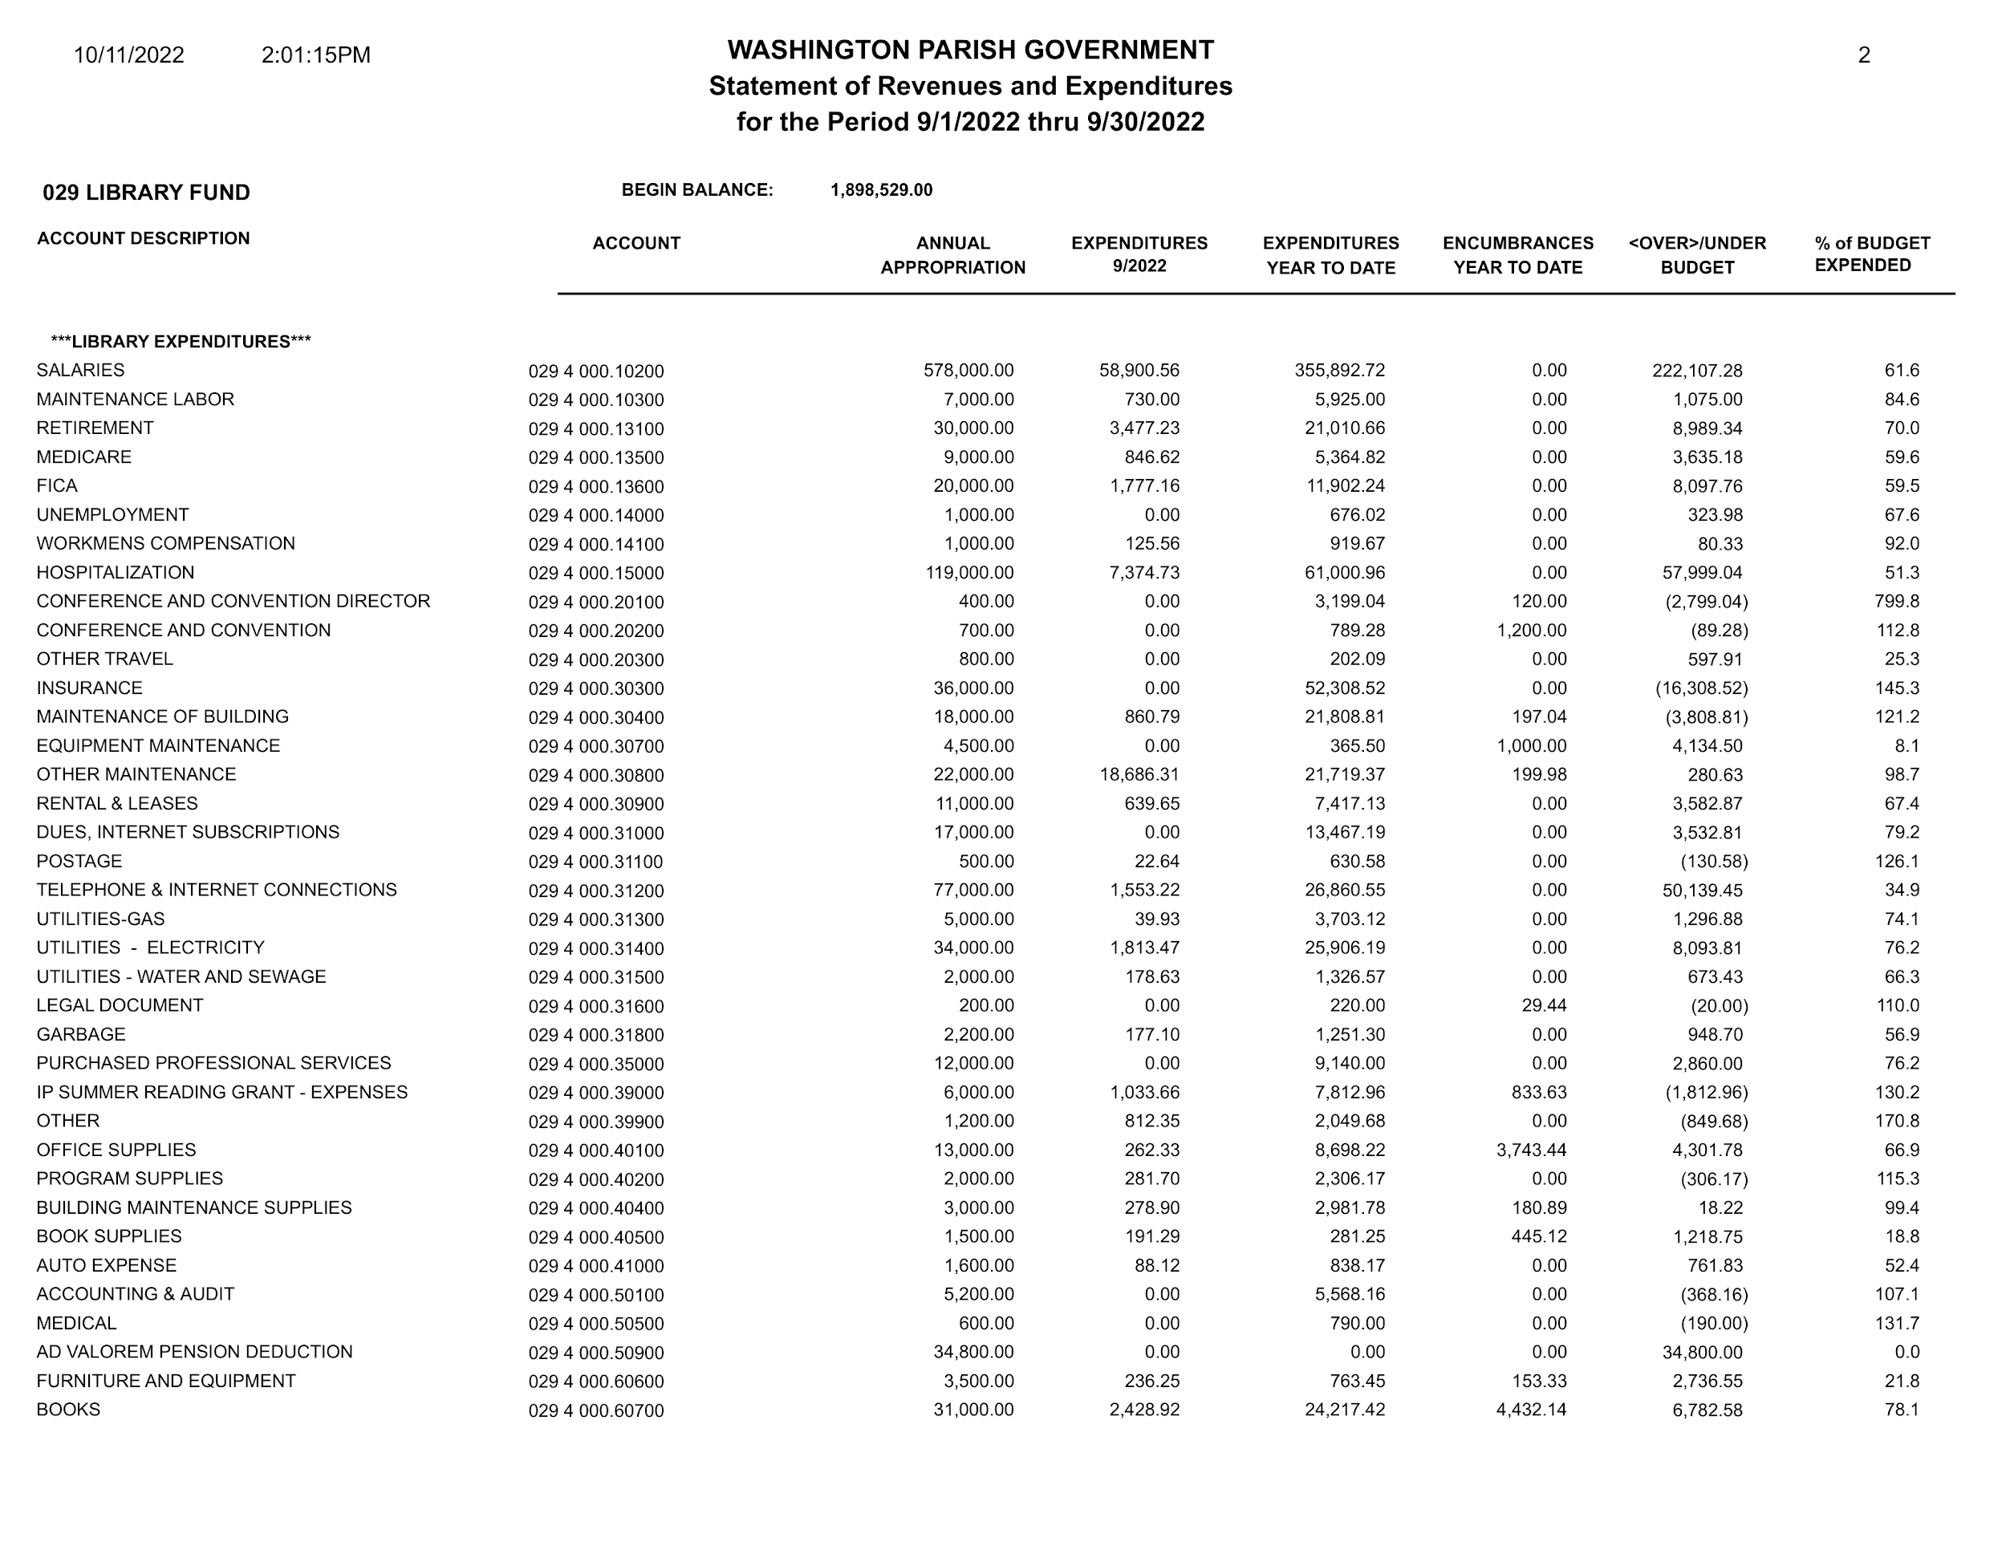
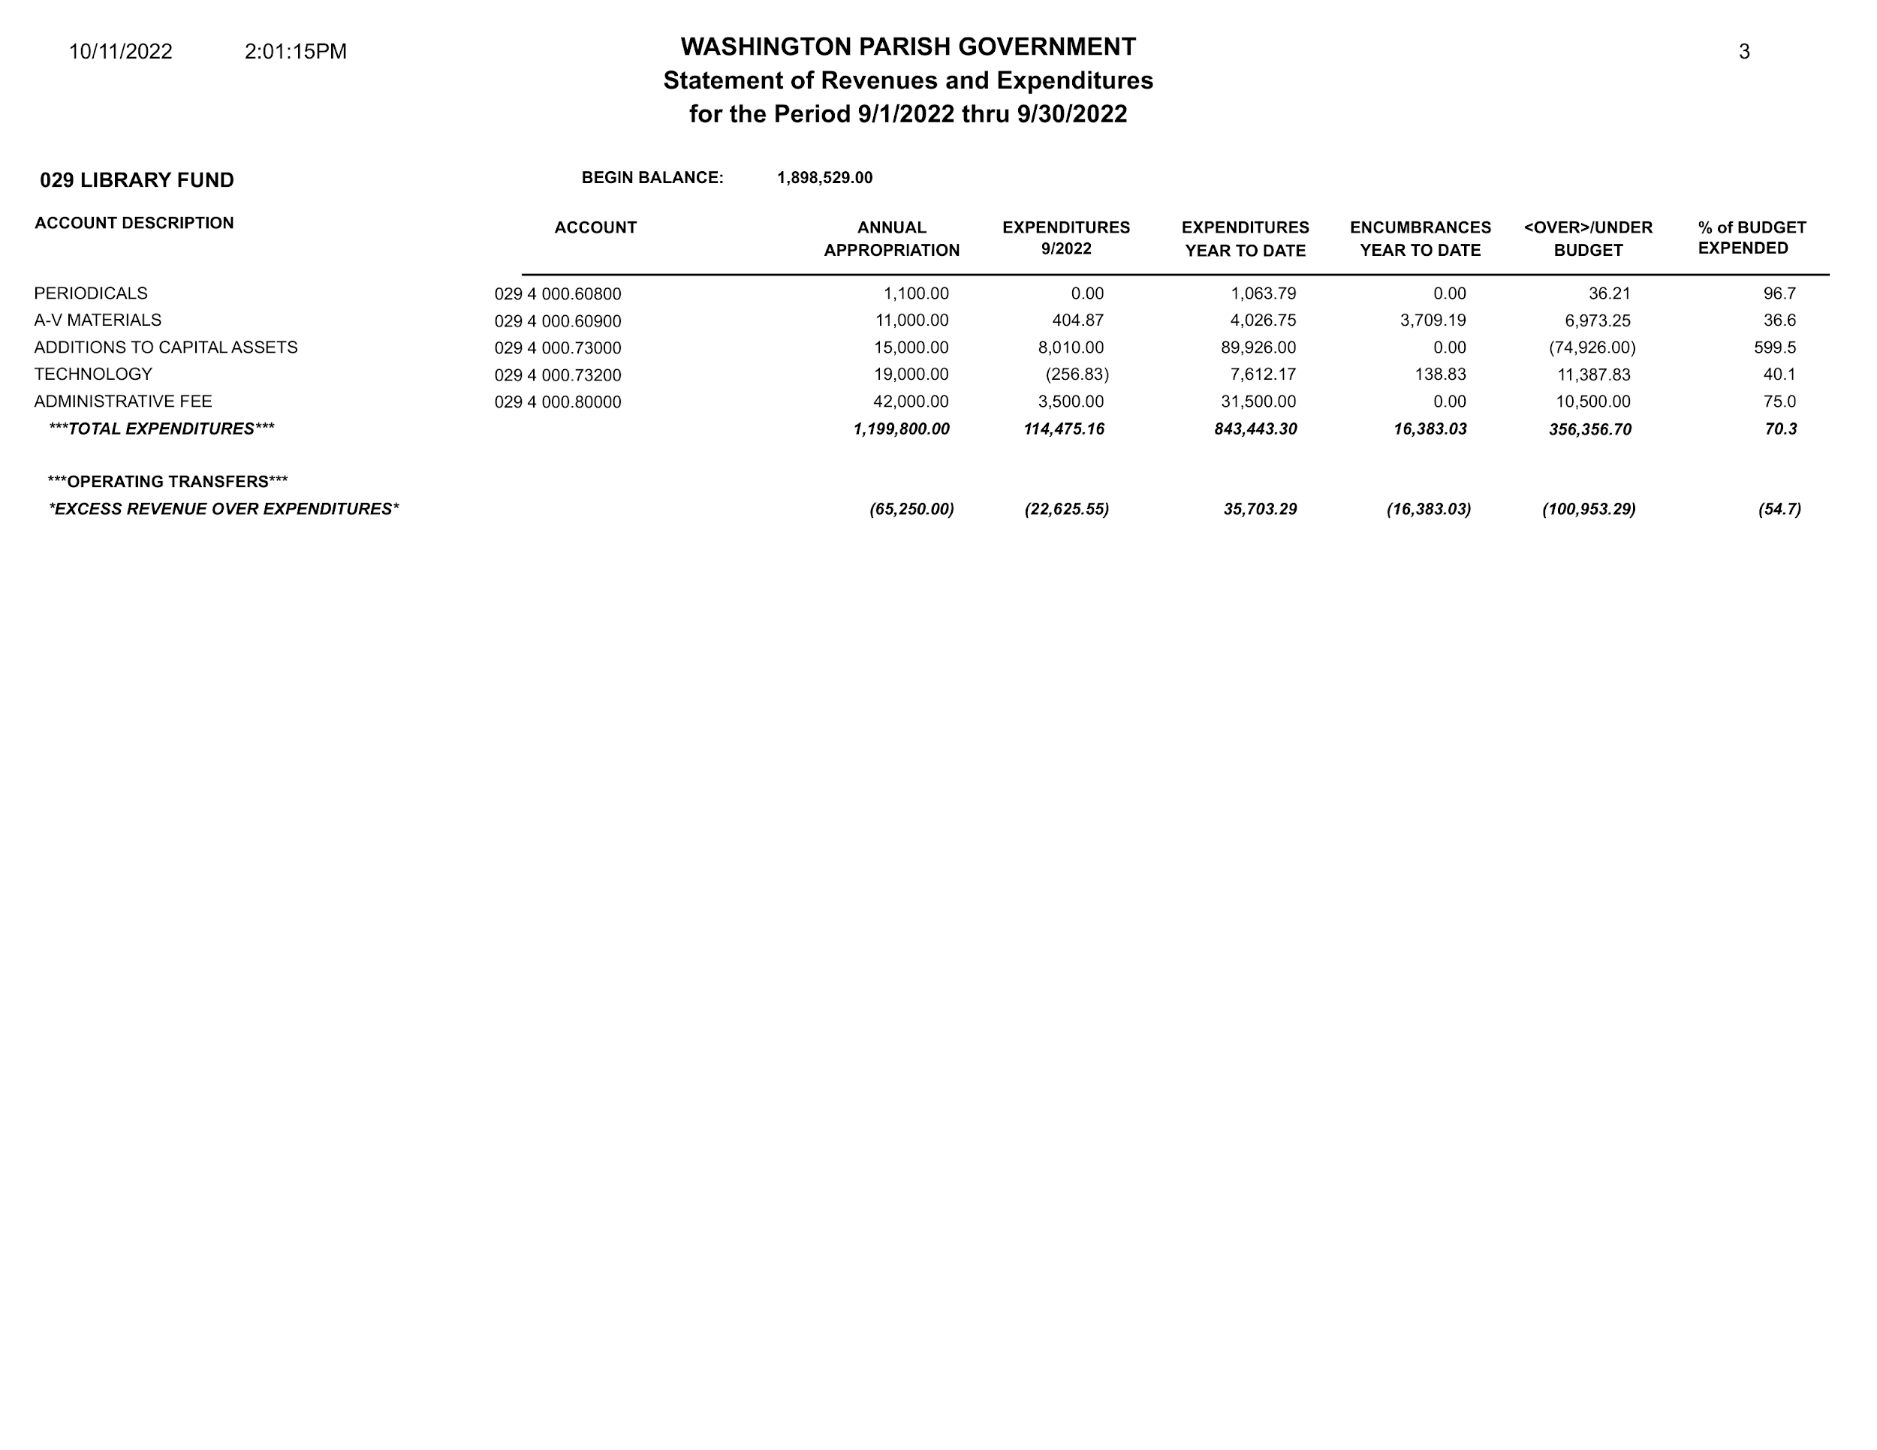

Washington Parish Library
Library Board of Control
Franklinton Branch
Thursday, November 17, 2022, 5:30pm
Meeting Minutes

- Call to Order by Mr. Jim Adams at 5:30pm.

- Roll Call by Mrs. Sonnet Ireland.
Board Members present: Mr. Jim Adams, Ms. Kewanda August, Mrs. Suzie Betts, Ms. Penny Moses, Ms. Emma Ross, and Mr. Donald Westmoreland
Board Members absent: Mrs. Sally Thomas

- Invocation by Ms. Ross.

- Pledge of Allegiance by Mr. Westmoreland.

- Approval of Minutes
A motion was made by Ms. Moses to accept the October 28, 2022 minutes as written; seconded by Ms. Ross. All present Board Members agreed. Motion passed.

- Director’s Report (See Attached Report)

- Bulletins/Correspondence

- Unfinished Business
  - Update on Bogalusa covering
Metal flashing has been put around the end of the walkway on top near the front door. It seems to have stopped leaking.

  - Part-timer benefits
Mrs. Ireland had previously requested the Board consider returning Holiday Pay to the part-time employees, explaining that morale has been at an all-time low since the changes were made by the Board a few years ago. Ms. Ross advocated for returning holiday pay to the part-timers, as they are vital to the function of the Library. Mrs. Betts also voiced the concern that the part-timers working at the Library at the time of the change (early 2020) were not grandfathered in. Mr. Adams agreed to entertain a motion to offer a trial run of holiday pay to the part-timers for the Thanksgiving and Christmas holidays this year, as long as none of the part-timers went over 27 hours for the weeks where holiday pay was granted. The Board would then assess the situation at the January meeting.
A motion was made by Mrs. Betts to have a trial run of part-timers receiving holiday pay for Thanksgiving and Christmas this year and reassess the situation in January; seconded by Ms. Ross.
Mr. Jim Adams: Yes
Mrs. Sally Thomas: Absent
Ms. Kewanda August: Yes
Mrs. Suzie Betts: Yes
Ms. Penny Moses: Yes
Ms. Emma Ross: Yes
Mr. Donald Westmoreland: Yes
Motion passed.
- New Business
  - 2023 Holiday Schedule
A motion was made by Mr. Westmoreland to accept the 2023 Holiday Calendar presented; seconded by Ms. August. All present Board Members agreed. Motion passed.

  - 2023 LBOC Meeting Schedule
A motion was made by Ms. Moses to accept the 2023 LBOC Meeting Calendar presented with the option to change the locations of the meetings throughout the year; seconded by Ms. August. All present Board Members agreed. Motion passed.

  - Policy Updates
Mrs. Ireland updated four of the many Library policies. Mr. Adams said the Board should review them carefully for voting at the January meeting. These policies are available for review at local branches. They are:
    - Collection Development Policy
    - Challenged Material Policy
    - Distribution of Materials in the Library Policy
    - Display Policy

- Public Comment
Mrs. Etta Magee thanked the Board for reconsidering the issue of Holiday pay for part-timers.
Mrs. Jennifer Seals wanted to acknowledge and thank the Friends of the Washington Parish Library for their support and involvement.

- Adjournment
A motion was made to adjourn by Ms. August and seconded by Ms. Ross. All Board Members agreed. Motion passed. Meeting adjourned at 6:33pm.
The next meeting is scheduled for 5:30PM on Thursday, January 19, 2023 at the Bogalusa Branch.

Washington Parish Library
Director’s Report
Thursday, November 17, 2022
Library Activity
September 2022
Branch | Programs / Attendance | Checkouts | Reference Questions | Computer Use | Wifi | Patron Count
Bogalusa | 15 / 156 | 1189 | 91 | 619 | 2280 | 2676
Franklinton | 16 / 137 | 1378 | 24 | 382 | 2445 | 1931
Enon | 10 / 251 | 524 | 11 | 50 | 192 | 369
Thomas | 2 / 6 | 179 | - | 12 | 983 | 208
Total | 43 / 550 | 3,270 | 126 | 1,063 | 5,900 | 5,184

October 2022
Branch | Programs / Attendance | Checkouts | Reference Questions | Computer Use | Wifi | Patron Count
Bogalusa | 14 / 315 | 1035 | 40 | 457 | 2065 | 2176
Franklinton | 17 / 788 | 1196 | 21 | 297 | 2382 | 2219
Enon | 11 / 352 | 496 | 10 | 48 | 118 | 381
Thomas | 5 / 310 | 124 | - | 7 | 805 | 319
Total | 47 / 1,765 | 2,851 | 71 | 809 | 5,370 | 5,095
Totals as of November 1, 2022
 | Events | Attendance | Checkouts | Reference | Computer Use | Wifi | Patron Count
Jan | 31 | 1,080 | 2,366 | 45 | 980 | 11,362 | 3,325
Feb | 47 | 1,539 | 2,498 | 32 | 914 | 1,926 | 3,841
Mar | 40 | 1,136 | 2,992 | 90 | 1,002 | 2,146 | 4,365
Apr | 42 | 1,642 | 3,180 | 36 | 946 | 5,503 | 4,043
May | 35 | 943 | 3,807 | 48 | 946 | 4,269 | 4,854
Jun | 108 | 3,211 | 4,673 | 119 | 1,093 | 3,688 | 6,209
 | Events | Attendance | Checkouts | Reference | Computer Use | Wifi | Patron Count
Jul | 61 | 1,549 | 3,620 | 68 | 1,019 | 6,135 | 4,878
Aug | 49 | 494 | 3,243 | 96 | 1,238 | 6,522 | 5,400
Sep | 43 | 550 | 3,270 | 126 | 1,063 | 5,900 | 5,184
Oct | 47 | 1765 | 2,851 | 71 | 809 | 5,370 | 5,095
YTD | 503 | 13,909 | 32,500 | 731 | 10,010 | 52,821 | 47,194

Library Staff

Professional Development
The four branch managers, Lahoma Dawson, Bonnie Dier, Winola Holliday, and Marsha Miley, have completed the 10-week Supervision and Management course they were taking with the State Library.
Staff have attended - 26 Webinars/Trainings since the last Board meeting.
Aerial and Sonnet attended the e-rate training in Baton Rouge: E-Rate for Beginners and E-Rate for Advanced Applicants.
Etta and Aerial attended the Fall Administrative Conference at the State Library.
Etta and Sonnet attended a Capital Area Digital Equity Engagement Event, which focused on stakeholders providing feedback on the development of Louisiana’s Statewide Digital Equity Plan.
Sonnet started the 10-week Library Privacy Programs and Training Crash Course through the Library Freedom Project (LFP).
Sonnet attended the Library Advocacy and Funding Conference (LAFCON).

Outreach
The Library participated in the 2022 Bogalusa Blues & Heritage Festival (September 23-24), the 2022 Washington Parish Fair (October 19-22), and Bogalusa’s Business on the Block Party (October 28).
Staff also engaged in outreach with Sandy’s Kidz, Mimi’s Childcare, Head Start, and the Franklinton Association for Challenged Citizens Activity Center

Updates
Angie: The Parish Council voted in favor of the purchase of the building in Angie. Last I heard, Mr. Kuhn was completing the title work on Monday, November 14th. We would close soon thereafter.
Bogalusa Walkway Covering: It looks like metal flashing has been put around the end of the walkway on top near the front door. It seems to have stopped leaking.

In the News
“Franklinton library holds recipe swap.” The Bogalusa Daily. Monday, November 14, 2022.
https://www.bogalusadailynews.com/2022/11/14/franklinton-library-holds-recipe-swap/

“Letter to the Editor: Pride in our parish, and in our libraries.” The Bogalusa Daily. Friday, October 28, 2022.
https://www.bogalusadailynews.com/2022/10/28/letter-to-the-editor-pride-in-our-parish-and-in-our-libraries/

“Al Barron, Librarian.” The Era-Leader. Thursday, October 6, 2022. https://www.era-leader.com/columns/al-barron-librarian

Finance Report
The E-Rate Reimbursement (029 3 502) doesn’t seem correct. Because of how the E-Rate program works, it doesn’t align as well with the rest of the items under Revenue. Etta is currently looking into how much the “Collected, Year to Date” number should be, and we will talk to Donna about it once we have an accurate number.

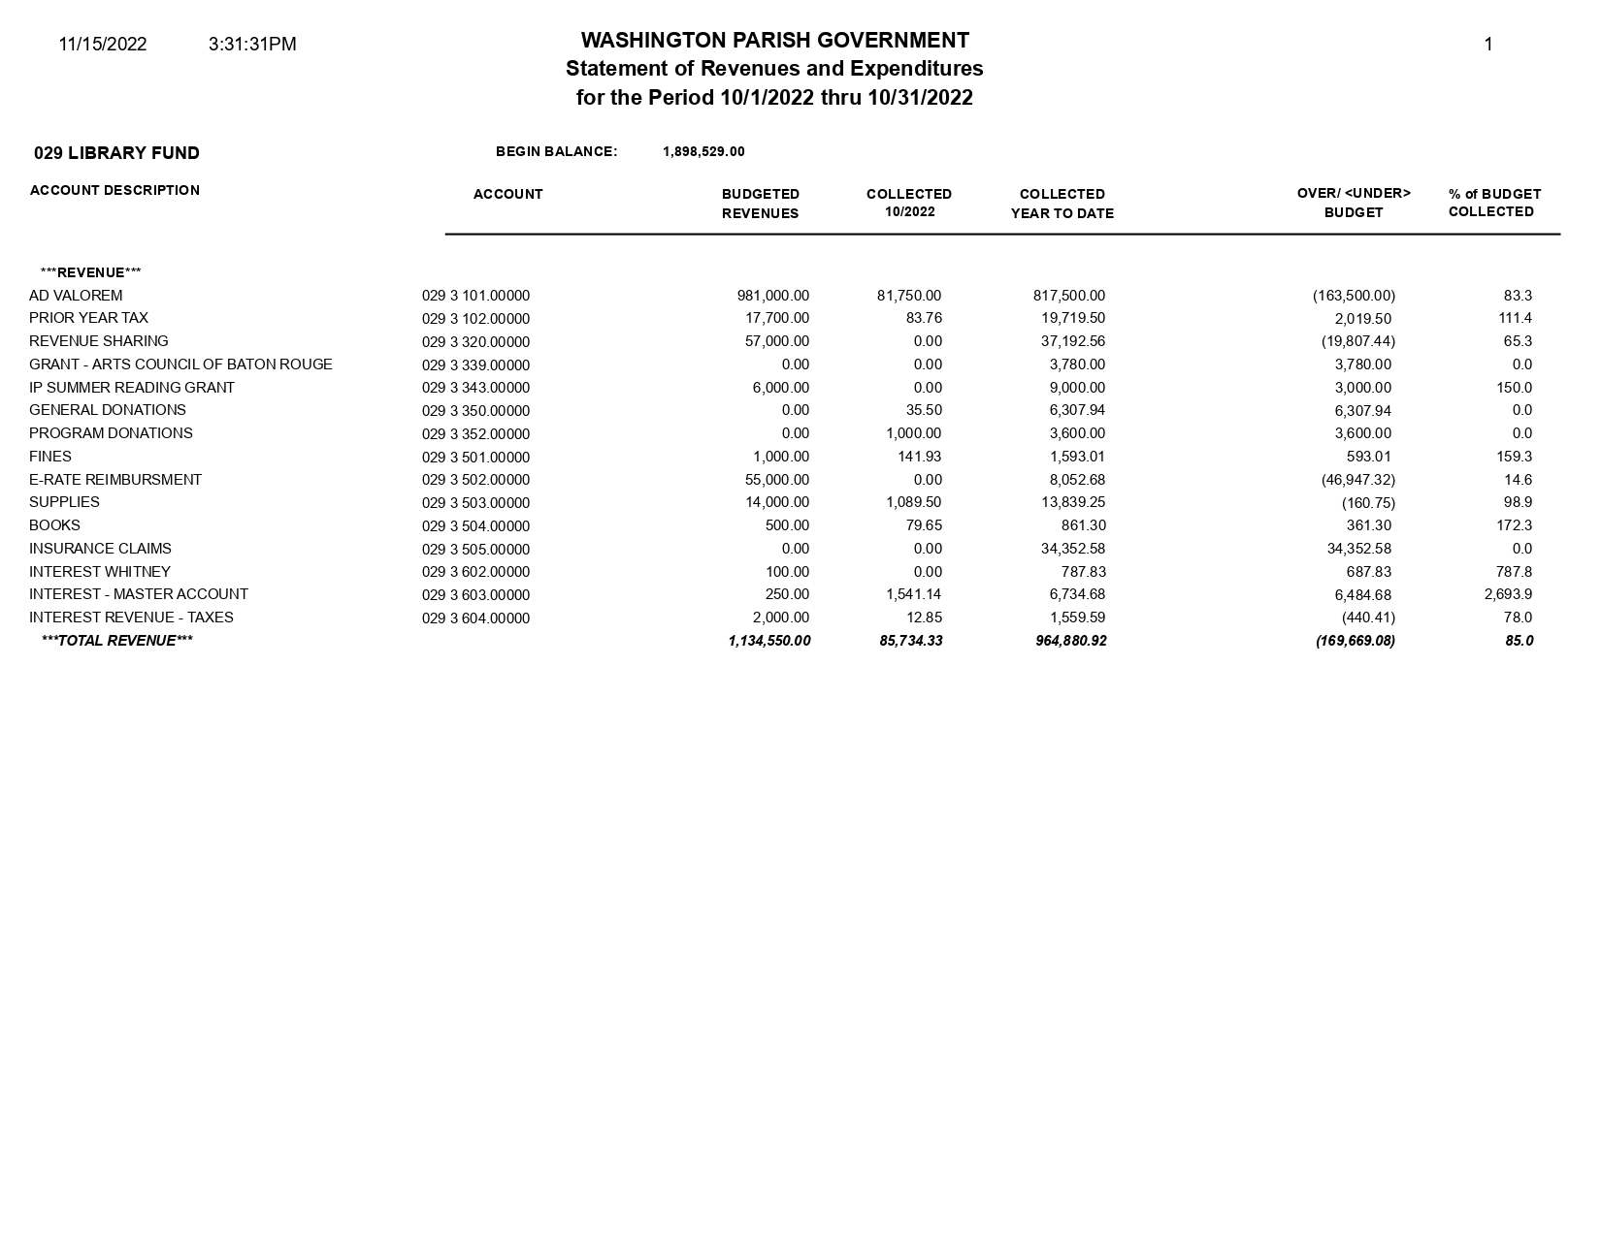
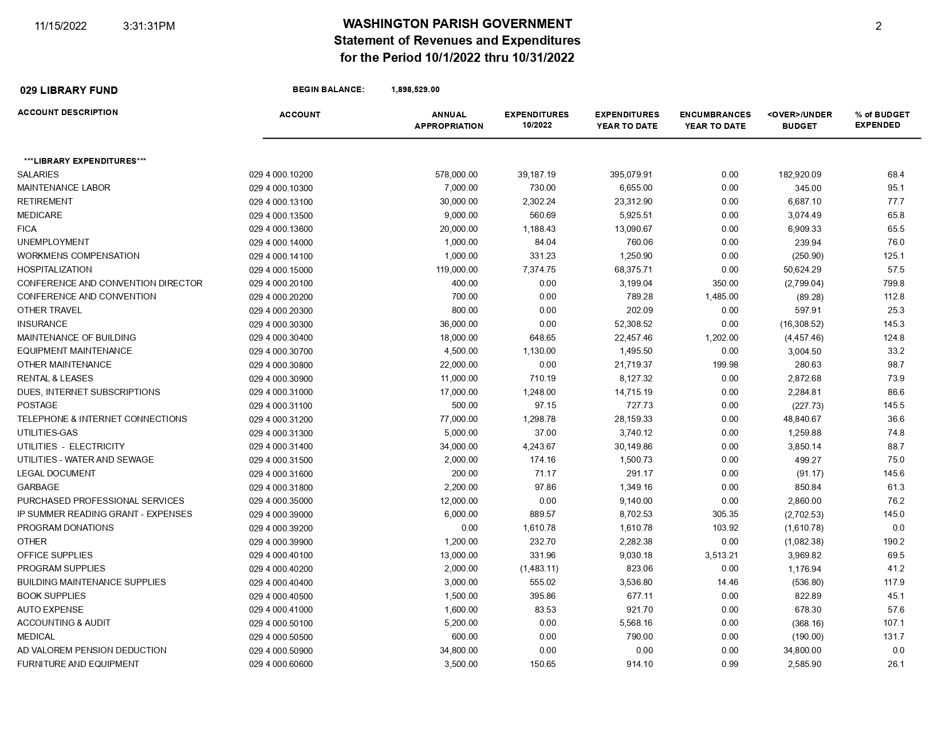
Washington Parish Library
2023 Holiday Schedule

Monday, January 2, 2023 New Year’s Day (Observed)

Monday January 16, 2023 Martin Luther King Day

Saturday, February 18, 2023 Bogalusa Branch Closed - MCCA Parade @ 1pm

Tuesday, February 21, 2023 Mardi Gras Day

Friday, April 7, 2023 Good Friday
Saturday, April 8, 2023 Library Closure (Easter )

Monday, May 29, 2023 Memorial Day

Monday, June 19, 2023 Juneteenth

Tuesday, July 4, 2023 Independence Day

Monday, September 4, 2023 Labor Day

Monday, October 9, 2023 Library Closed for All Staff Training Day

October 18-21, 2023 Washington Parish Fair

November 23-24, 2023 Thanksgiving

Saturday, November 25, 2023 Library Closure (Thanksgiving)

Saturday, December 23 Library Closure (Christmas Holidays)
December 25-27, 2023 Christmas

Friday, December 29, 2023 New Year’s Eve
Saturday, December 30, 2023 Library Closure

Washington Parish Library
Library Board of Control
2023 Meeting Schedule

Regular meetings of the Washington Parish Library Board of Control (LBOC) are held at 5:30pm on the third (3rd) Thursday of every other month and are rotated amongst the branches of the Library. Special meetings of the LBOC may be called as needed to conduct special Library business.

Thursday, January 19, 2023 - Bogalusa Branch

Thursday, March 16, 2023 - Franklinton Branch

Thursday, May 18, 2023 - Angie Branch

Thursday, July 20, 2023 - Bogalusa Branch

Thursday, September 14, 2023 - Franklinton Branch

Thursday, November 16, 2023 - Enon Branch

*Locations may be subject to change.

WASHINGTON PARISH LIBRARY
Collection Development Policy

The Washington Parish Library supports and follows the American Library Association's Bill of Rights and its Freedom to Read and Freedom to View statements, which recognize the right of persons to free and convenient access to information and ideas.

It is the responsibility of the Washington Parish Library to develop a collection that strives, within the limitations of budget and space, to provide a wide range of materials which meet the diverse educational, informational, cultural, and recreational needs of the community. To meet that responsibility, this policy provides guidelines to be used in the selection and retention of material in the Library.
Selection Policy
A public library attempts to provide an accessible setting for a variety of materials.
Since no individual can buy and store all of the material one may need or want, the
community pools its resources to create a public collection for the community's benefit. The Washington Parish Library uses various tools, such as Reciprocal Borrowing Agreements and InterLibrary Loan (ILL), to enhance the Library collection and ensure access to items the community might not otherwise acquire.

- Selection Library materials is the responsibility of the Library Director and, through their direction, the Branch Managers with input from their staff as appropriate.
- Selection and retention of books and other materials shall be made according to the value that material has to the interest, information, recreation, and enlightenment for all the people of Washington Parish. No book or other material shall be excluded or removed because of the race, nationality, sex, or political, social, or religious views of the author.
- Selection and retention of Library materials shall not be responsive or contingent on approval of or pressure from any single individual or group of individuals. The collection is a resource for all the people of the parish, and as such cannot respond to the wishes, beliefs, or tenets of any one individual or group of individuals.
- Because we serve the entire community of Washington Parish Library, and because diversity in materials has proven to lead children and adults to appreciate their own culture as well as those of others, the Library shall curate a diverse and inclusive collection to reflect the viewpoints of our community and the world at large.
- Choice of reading, viewing, or listening material is a highly individualized action. Everyone is free to choose material for personal use and to reject that which they find offensive. However, no one may seek to censor, or restrict the access to that material for the free use of others. Freedom of access for minors is the responsibility of the parents or legal guardians, not the Library Director, the Library Staff, nor the Library Board of Control.
- The Library Board reaffirms the principles of the “Freedom to Read” statement.
- The Library Board has adopted and reaffirms the “Library Bill of Rights.”
- Suggestions from the public regarding the selection and retention of materials shall be seriously considered and be reviewed by appropriate Library Staff for inclusion in the collection.
- The Library staff is constantly gathering information concerning the needs of Library users by means of circulation statistics, interLibrary loan requests, and patron input.
- Works that present an aspect of life honestly will not necessarily be excluded because of visual format, coarse language or frankness of expression. While these materials may, at times, be controversial, they will not be excluded.
- Materials will be judged as a whole rather than on isolated passages.
- Materials may not be added to the collection solely to meet the demand for specific school assignments.
- All materials added to the collection, whether purchases or gifts, shall meet the same criteria.

General Principles Of Selection
The following basic standard criteria are considered in recommending titles for purchase
and establishing the overall value of a title.

- Customer interest.
- Literary merit, determined by reviews in professional journals or popular periodicals, by their inclusion in Best Seller lists, and/or by their status as a winner or nominee for one or more local, state, national, or international awards.
- Authoritativeness: Authors’ reputation and significance as writers, or their knowledge of the subject.
- Accuracy of information for non-fiction materials.
- Importance of subject matter to the collection.
- Timeliness or permanence of the title.
- Appearance of title in special bibliographies or indexes.
- Existing subject matter in the collection.
- Absence of subject matter in the collection.
- Cost of the item and available shelf space.

Self-Published Books
While self-published materials have historically been excluded from Library collections, the changing nature of publishing calls for Libraries to adapt. Self-published fiction titles shall also be considered for inclusion to the Library Collection, particularly those by local authors or those reviewed positively in a major review journal, depending on the Library’s collection criteria and needs. Self-published non-fiction titles may be considered with extensive research into the accuracy of the publication. Paid reviews or customer reviews, from such stores as Amazon, shall never be used as a consideration for inclusion in the Library Collection.

Periodicals
- Periodicals are often the most current source of information that has not yet been published or may not appear in book form. An important consideration is the availability of the contents through indexes, abstracts and bibliographies.
- Because of the expense involved in subscribing to periodicals, titles may be canceled or replaced based on usage or lack thereof.
- Newspapers are a valuable material and source of local and regional information. The number of papers must be limited by the amount of storage available.
Children and Teen Materials
The Library develops collections aimed at the special interests, tastes, and backgrounds of all children (infancy through age 12) and teens (ages 13-17). Materials in this collection should assist the child or teen in the development of mental capacities and social skills.
The parents or guardians, not the Library, are responsible for supervising the use of Library materials by their children. Library Staff are available to provide suggestions for caregivers and their children with the guidance of professional journals and websites.

Gifts, Donations, and Memorials
Gift materials are received routinely by the Library with the provision that they may be used in the best interest of the Library. They are accepted without conditions or restrictions. Donated materials may or may not be added to the collection. Materials not added to the collection may be included in book sales or donated to other community programs. All proceeds from these book sales are used in support of the Library’s mission, programs, and collections.

Monetary donations allocated for materials purchase are also accepted by the Library.

Memorials and honorariums are a meaningful and lasting way to pay homage to someone; however, these materials must also meet the selection criteria in this policy. Patrons are invited to discuss their wishes with Library Administration and Branch Managers before purchasing an item, or preferably, allowing selection staff to choose the item being purchased. Involving staff will ensure that the selected item fits collection needs and criteria.

Gifts, memorials, honorariums, and donations are all subject to the same selection criteria and withdrawal policy as items purchased by the Library. The Library reserves the right to determine the disposition of all gifts, donations, and memorials received, in keeping with the policy herein.

Withdrawal of Materials
The Library Board recognizes that withdrawing materials from the collection is an important part of maintaining the Library Collection with relevant and up-to-date information. Withdrawal of materials is a responsibility vested in the Library Director and, through their direction, the Branch Managers. The withdrawal of materials policy is based on the same factors as the selection policy with an emphasis on usage and accuracy. This ensures the collection stays current, relevant, and in good condition. Withdrawn materials in good condition are included in Library book sales or donated to other community programs.

Washington Parish Library
Challenged Material Policy

The Washington Parish Library does not endorse opinions contained in its materials. Patrons are free to enjoy, dislike, or ignore any item in the collection. However, no one is free to restrict the community’s use of Library materials.

The selection of Library materials is predicated on the Library customers’ right to read, and similarly, their freedom from censorship by others. Many titles are controversial, and any given item may offend some persons. Selections for the Washington Parish Library will not, however, be made on the basis of anticipated approval or disapproval, but solely on the merits of the material in relation to building the collection and to serving the interests of the readers.

This Library holds censorship to be a purely individual matter that should be free of government interference and declares that--while all are free to reject for themselves books and other materials of which they do not approve--they cannot exercise this right of censorship to restrict the freedom of others.

With respect to the use of the Library materials by children, the decision as to what minors may read, view, or listen to is the responsibility of their parents or guardians. The Library staff can not and will not serve in loco parentis. Parental opinions on what is acceptable reading for children vary widely. Selection will not be inhibited by the possibility that books may come into the possession of minors.

A request to remove Library materials creates complex legal and ethical questions for both the Library and the community. Consequently, this issue is taken very seriously by the Library.

Process

- Patrons questioning material may speak to Library Staff about an item. The supervisor in charge will discuss the patron’s concerns and give the patron a copy of this policy and the Washington Parish Library Collection Development Policy.
- If the patron wishes to continue questioning the material, staff will provide a “Request for Reconsideration of Library Materials” form on which they may state their opinion in writing.
- Only fully completed forms will be accepted.
- One form must be completed for each item a patron has questioned.
- Staff is available to assist in preparation of the required forms.
- Once completed, the form and the material in question will be sent to the Library Director.
- The Library Director will then appoint a committee to review the challenged material and prepare a written report. Until a decision is reached by the Library Director, the item in question will remain available.
- After complete examination of the material, which includes reading or viewing the content, the gathering of professional reviews, and any other necessary research, the committee will make a recommendation to the Library Director.
- The Library Director will provide the decision in writing to the person listed on this form.
- Patrons who do not accept the Library Director's decision may appeal to the Library Board of Control during a regular meeting of the Library Board under the agenda item “Public Comment” or at another time designated by the Library Board for public expression.
- The Library Board, after receiving testimony from the public and from the Library Director, will decide the Library’s actions, in accordance with Library policies.
- Possible actions that may be taken when warranted are:
a) No change in status of the item
b) Re-classification and placement in another area of the Library
c) Replacement with another item which better covers this subject and better meets the needs of the community.
- All concerns about the results of a Request for Reconsideration should be directed to the Library Director and/or the Library Board of Control and not to Library Staff.

WASHINGTON PARISH LIBRARY
Distribution Of Materials And Posting Of Announcements
Within The Library Policy

From time to time, the Washington Parish Library is asked to post or make available for distribution announcement flyers or other materials from organizations or individuals promoting their activities or points of view. Distribution or posting of these materials by the Library does not necessarily indicate the Library’s endorsement of the issues or events promoted by those materials.

Priorities

The Library strives to provide, within the space limitations of each branch, a space for flyers and other such materials while observing the following guidelines.

- Our first priority for our public forum space is for materials about Library services, programs, and events;
- Our second priority for our public forum space is for materials from the Friends of The Washington Parish Library;
- Our third priority for our public forum space is for materials from other governmental entities such as the parish, state and federal governments;
- Our fourth priority for our public forum space is for materials advertising local cultural activities, festivals, and programs sponsored by civic organizations;
- Our final priority for available space is for information from other groups which must meet guidelines as stated below.

Guidelines and Prohibitions
- All requests for display of announcements/posters, etc. from outside the Library will be directed to Administration for a decision on display.
- No item may be hung or displayed without prior approval. Any material placed in the Library without approval will be removed and discarded.
- Material that is displayed will be dated on the first day of display and will be removed after one month or the day after the day of the event advertised.
- No political or religious events or viewpoints will be advertised or distributed in the Library or on Library grounds. This includes materials that support or oppose any current or pending ballot measure or political candidate, as well as materials asking Library visitors to sign a petition or letter.
- Official election information, however, such as items from the League of Women Voters or the Public Affairs Research Council Of Louisiana, shall be made available in the Library.
- Advertisements from profit making groups will be limited to those that provide an educational, cultural, or civic service (e.g., tutoring, plays, lectures, concerts, etc.) that are open to the general public. These will be posted only if space is available.
- Local newspapers and magazines of a non-commercial, non-partisan, and non-religious nature as determined by Administration.
- The Library assumes no responsibility for the preservation or protection of materials posted or distributed. Materials will not be returned.
- The Library Director, or their designee, is responsible for the administration of this policy on a system-wide basis. Branch managers are responsible for the administration of this policy within their facilities.
- All materials posted or distributed must comply with this policy and any other applicable Library regulations or guidelines. No other materials may be posted or distributed.

WASHINGTON PARISH LIBRARY
Library Displays Policy

According to the American Library Association, “Library-initiated programs support the mission of the Library by providing users with additional opportunities for accessing information, education, and recreation. Library displays increase awareness of programs, resources, and services.”

- Displays in the Library shall be developed and prepared by the Library staff under the direction/approval of Administration. Displays will highlight activities or events of local, regional, or national interest.

- The Library Director shall have final authority, approval or rejection of any display in the Library.

- Displays should be changed regularly to keep the interest and engagement of the community.

- Because we serve the entire community of Washington Parish Library, and because diversity in materials has proven to lead children and adults to appreciate their own culture as well as those of others, the Library shall curate creative and inviting displays as one of many tools to reflect the diversity of members and viewpoints of our community.

- No displays shall be partisan in their viewpoints, or present or advocate for a single religion’s viewpoints.

- Displays are meant to educate, inform, and entertain; they do not necessarily reflect the stance of the Library or the Washington Parish Government.

- The length of time any material is on display will be determined by Branch Management with the guidance of the Library Administration.

